[oracle@rac1 grid]$ ./runcluvfy.sh stage -pre crsinst -upgrade -n rac1,rac2 -rolling -src_crshome /u01/app/11.2.0/grid -dest_crshome /u01/app/11.2.0.4/grid -dest_version 11.2.0.4.0 -verbose

Performing pre-checks for cluster services setup

Checking node reachability...

Check: Node reachability from node "rac1"
Destination Node Reachable?
------------------------------------ ------------------------
rac2 yes
rac1 yes
Result: Node reachability check passed from node "rac1"

Checking user equivalence...

Check: User equivalence for user "oracle"
Node Name Status
------------------------------------ ------------------------
rac2 passed
rac1 passed
Result: User equivalence check passed for user "oracle"

Checking CRS user consistency
Result: CRS user consistency check successful

Checking node connectivity...

Checking hosts config file...
Node Name Status
------------------------------------ ------------------------
rac2 passed
rac1 passed

Verification of the hosts config file successful

Interface information for node "rac2"
Name IP Address Subnet Gateway Def. Gateway HW Address MTU
------ --------------- --------------- --------------- --------------- ----------------- ------
eth0 192.168.2.102 192.168.2.0 0.0.0.0 192.168.2.1 08:00:27:9C:6D:05 1500
eth0 192.168.2.104 192.168.2.0 0.0.0.0 192.168.2.1 08:00:27:9C:6D:05 1500
eth0 192.168.2.107 192.168.2.0 0.0.0.0 192.168.2.1 08:00:27:9C:6D:05 1500
eth1 192.168.0.102 192.168.0.0 0.0.0.0 192.168.2.1 08:00:27:41:2A:C4 1500
eth1 169.254.157.23 169.254.0.0 0.0.0.0 192.168.2.1 08:00:27:41:2A:C4 1500

Interface information for node "rac1"
Name IP Address Subnet Gateway Def. Gateway HW Address MTU
------ --------------- --------------- --------------- --------------- ----------------- ------
eth0 192.168.2.101 192.168.2.0 0.0.0.0 192.168.2.1 08:00:27:B1:FF:0A 1500
eth0 192.168.2.106 192.168.2.0 0.0.0.0 192.168.2.1 08:00:27:B1:FF:0A 1500
eth0 192.168.2.105 192.168.2.0 0.0.0.0 192.168.2.1 08:00:27:B1:FF:0A 1500
eth0 192.168.2.103 192.168.2.0 0.0.0.0 192.168.2.1 08:00:27:B1:FF:0A 1500
eth1 192.168.0.101 192.168.0.0 0.0.0.0 192.168.2.1 08:00:27:AA:85:56 1500
eth1 169.254.40.171 169.254.0.0 0.0.0.0 192.168.2.1 08:00:27:AA:85:56 1500

Check: Node connectivity for interface "eth0"
Source Destination Connected?
------------------------------ ------------------------------ ----------------
rac2[192.168.2.102] rac2[192.168.2.104] yes
rac2[192.168.2.102] rac2[192.168.2.107] yes
rac2[192.168.2.102] rac1[192.168.2.101] yes
rac2[192.168.2.102] rac1[192.168.2.106] yes
rac2[192.168.2.102] rac1[192.168.2.105] yes
rac2[192.168.2.102] rac1[192.168.2.103] yes
rac2[192.168.2.104] rac2[192.168.2.107] yes
rac2[192.168.2.104] rac1[192.168.2.101] yes
rac2[192.168.2.104] rac1[192.168.2.106] yes
rac2[192.168.2.104] rac1[192.168.2.105] yes
rac2[192.168.2.104] rac1[192.168.2.103] yes
rac2[192.168.2.107] rac1[192.168.2.101] yes
rac2[192.168.2.107] rac1[192.168.2.106] yes
rac2[192.168.2.107] rac1[192.168.2.105] yes
rac2[192.168.2.107] rac1[192.168.2.103] yes
rac1[192.168.2.101] rac1[192.168.2.106] yes
rac1[192.168.2.101] rac1[192.168.2.105] yes
rac1[192.168.2.101] rac1[192.168.2.103] yes
rac1[192.168.2.106] rac1[192.168.2.105] yes
rac1[192.168.2.106] rac1[192.168.2.103] yes
rac1[192.168.2.105] rac1[192.168.2.103] yes
Result: Node connectivity passed for interface "eth0"

Check: TCP connectivity of subnet "192.168.2.0"
Source Destination Connected?
------------------------------ ------------------------------ ----------------
rac1:192.168.2.101 rac2:192.168.2.102 passed
rac1:192.168.2.101 rac2:192.168.2.104 passed
rac1:192.168.2.101 rac2:192.168.2.107 passed
rac1:192.168.2.101 rac1:192.168.2.106 passed
rac1:192.168.2.101 rac1:192.168.2.105 passed
rac1:192.168.2.101 rac1:192.168.2.103 passed
Result: TCP connectivity check passed for subnet "192.168.2.0"

Check: Node connectivity for interface "eth1"
Source Destination Connected?
------------------------------ ------------------------------ ----------------
rac2[192.168.0.102] rac1[192.168.0.101] yes
Result: Node connectivity passed for interface "eth1"

Check: TCP connectivity of subnet "192.168.0.0"
Source Destination Connected?
------------------------------ ------------------------------ ----------------
rac1:192.168.0.101 rac2:192.168.0.102 passed
Result: TCP connectivity check passed for subnet "192.168.0.0"

Checking subnet mask consistency...
Subnet mask consistency check passed for subnet "192.168.2.0".
Subnet mask consistency check passed for subnet "192.168.0.0".
Subnet mask consistency check passed.

Result: Node connectivity check passed

Checking multicast communication...

Checking subnet "192.168.2.0" for multicast communication with multicast group "230.0.1.0"...
Check of subnet "192.168.2.0" for multicast communication with multicast group "230.0.1.0" passed.

Checking subnet "192.168.0.0" for multicast communication with multicast group "230.0.1.0"...
Check of subnet "192.168.0.0" for multicast communication with multicast group "230.0.1.0" passed.

Check of multicast communication passed.

Checking OCR integrity...

OCR integrity check passed

Checking ASMLib configuration.
Node Name Status
------------------------------------ ------------------------
rac2 passed
rac1 passed
Result: Check for ASMLib configuration passed.

Check: Total memory
Node Name Available Required Status
------------ ------------------------ ------------------------ ----------
rac2 2.942GB (3084864.0KB) 1.5GB (1572864.0KB) passed
rac1 2.942GB (3084864.0KB) 1.5GB (1572864.0KB) passed
Result: Total memory check passed

Check: Available memory
Node Name Available Required Status
------------ ------------------------ ------------------------ ----------
rac2 2.1928GB (2299328.0KB) 50MB (51200.0KB) passed
rac1 1.9308GB (2024580.0KB) 50MB (51200.0KB) passed
Result: Available memory check passed

Check: Swap space
Node Name Available Required Status
------------ ------------------------ ------------------------ ----------
rac2 5.5385GB (5807488.0KB) 2.942GB (3084864.0KB) passed
rac1 5.5385GB (5807488.0KB) 2.942GB (3084864.0KB) passed
Result: Swap space check passed

Check: Free disk space for "rac2:/u01/app/11.2.0.4/grid"
Path Node Name Mount point Available Required Status
---------------- ------------ ------------ ------------ ------------ ------------
/u01/app/11.2.0.4/grid rac2 /u01 29.833GB 5.5GB passed
Result: Free disk space check passed for "rac2:/u01/app/11.2.0.4/grid"

Check: Free disk space for "rac1:/u01/app/11.2.0.4/grid"
Path Node Name Mount point Available Required Status
---------------- ------------ ------------ ------------ ------------ ------------
/u01/app/11.2.0.4/grid rac1 /u01 28.4668GB 5.5GB passed
Result: Free disk space check passed for "rac1:/u01/app/11.2.0.4/grid"

Check: Free disk space for "rac2:/tmp"
Path Node Name Mount point Available Required Status
---------------- ------------ ------------ ------------ ------------ ------------
/tmp rac2 / 5.5176GB 1GB passed
Result: Free disk space check passed for "rac2:/tmp"

Check: Free disk space for "rac1:/tmp"
Path Node Name Mount point Available Required Status
---------------- ------------ ------------ ------------ ------------ ------------
/tmp rac1 / 5.9735GB 1GB passed
Result: Free disk space check passed for "rac1:/tmp"

Check: User existence for "oracle"
Node Name Status Comment
------------ ------------------------ ------------------------
rac2 passed exists(1100)
rac1 passed exists(1100)

Checking for multiple users with UID value 1100
Result: Check for multiple users with UID value 1100 passed
Result: User existence check passed for "oracle"

Check: Group existence for "oinstall"
Node Name Status Comment
------------ ------------------------ ------------------------
rac2 passed exists
rac1 passed exists
Result: Group existence check passed for "oinstall"

Check: Membership of user "oracle" in group "oinstall" [as Primary]
Node Name User Exists Group Exists User in Group Primary Status
---------------- ------------ ------------ ------------ ------------ ------------
rac2 yes yes yes yes passed
rac1 yes yes yes yes passed
Result: Membership check for user "oracle" in group "oinstall" [as Primary] passed

Check: Run level
Node Name run level Required Status
------------ ------------------------ ------------------------ ----------
rac2 5 3,5 passed
rac1 5 3,5 passed
Result: Run level check passed

Check: Hard limits for "maximum open file descriptors"
Node Name Type Available Required Status
---------------- ------------ ------------ ------------ ----------------
rac2 hard 65536 65536 passed
rac1 hard 65536 65536 passed
Result: Hard limits check passed for "maximum open file descriptors"

Check: Soft limits for "maximum open file descriptors"
Node Name Type Available Required Status
---------------- ------------ ------------ ------------ ----------------
rac2 soft 1024 1024 passed
rac1 soft 1024 1024 passed
Result: Soft limits check passed for "maximum open file descriptors"

Check: Hard limits for "maximum user processes"
Node Name Type Available Required Status
---------------- ------------ ------------ ------------ ----------------
rac2 hard 16384 16384 passed
rac1 hard 16384 16384 passed
Result: Hard limits check passed for "maximum user processes"

Check: Soft limits for "maximum user processes"
Node Name Type Available Required Status
---------------- ------------ ------------ ------------ ----------------
rac2 soft 2047 2047 passed
rac1 soft 2047 2047 passed
Result: Soft limits check passed for "maximum user processes"

There are no oracle patches required for home "/u01/app/11.2.0/grid".

There are no oracle patches required for home "/u01/app/11.2.0.4/grid".

Check: System architecture
Node Name Available Required Status
------------ ------------------------ ------------------------ ----------
rac2 x86_64 x86_64 passed
rac1 x86_64 x86_64 passed
Result: System architecture check passed

Check: Kernel version
Node Name Available Required Status
------------ ------------------------ ------------------------ ----------
rac2 2.6.32-200.13.1.el5uek 2.6.18 passed
rac1 2.6.32-200.13.1.el5uek 2.6.18 passed
Result: Kernel version check passed

Check: Kernel parameter for "semmsl"
Node Name Current Configured Required Status Comment
---------------- ------------ ------------ ------------ ------------ ------------
rac2 250 250 250 passed
rac1 250 250 250 passed
Result: Kernel parameter check passed for "semmsl"

Check: Kernel parameter for "semmns"
Node Name Current Configured Required Status Comment
---------------- ------------ ------------ ------------ ------------ ------------
rac2 32000 32000 32000 passed
rac1 32000 32000 32000 passed
Result: Kernel parameter check passed for "semmns"

Check: Kernel parameter for "semopm"
Node Name Current Configured Required Status Comment
---------------- ------------ ------------ ------------ ------------ ------------
rac2 100 100 100 passed
rac1 100 100 100 passed
Result: Kernel parameter check passed for "semopm"

Check: Kernel parameter for "semmni"
Node Name Current Configured Required Status Comment
---------------- ------------ ------------ ------------ ------------ ------------
rac2 128 128 128 passed
rac1 128 128 128 passed
Result: Kernel parameter check passed for "semmni"

Check: Kernel parameter for "shmmax"
Node Name Current Configured Required Status Comment
---------------- ------------ ------------ ------------ ------------ ------------
rac2 1054504960 1054504960 1579450368 failed Current value incorrect. Configured value incorrect.
rac1 1054504960 1054504960 1579450368 failed Current value incorrect. Configured value incorrect.
Result: Kernel parameter check failed for "shmmax"

Check: Kernel parameter for "shmmni"
Node Name Current Configured Required Status Comment
---------------- ------------ ------------ ------------ ------------ ------------
rac2 4096 4096 4096 passed
rac1 4096 4096 4096 passed
Result: Kernel parameter check passed for "shmmni"

Check: Kernel parameter for "shmall"
Node Name Current Configured Required Status Comment
---------------- ------------ ------------ ------------ ------------ ------------
rac2 2097152 2097152 2097152 passed
rac1 2097152 2097152 2097152 passed
Result: Kernel parameter check passed for "shmall"

Check: Kernel parameter for "file-max"
Node Name Current Configured Required Status Comment
---------------- ------------ ------------ ------------ ------------ ------------
rac2 6815744 6815744 6815744 passed
rac1 6815744 6815744 6815744 passed
Result: Kernel parameter check passed for "file-max"

Check: Kernel parameter for "ip_local_port_range"
Node Name Current Configured Required Status Comment
---------------- ------------ ------------ ------------ ------------ ------------
rac2 between 9000.0 & 65500.0 between 9000.0 & 65500.0 between 9000.0 & 65500.0 passed
rac1 between 9000.0 & 65500.0 between 9000.0 & 65500.0 between 9000.0 & 65500.0 passed
Result: Kernel parameter check passed for "ip_local_port_range"

Check: Kernel parameter for "rmem_default"
Node Name Current Configured Required Status Comment
---------------- ------------ ------------ ------------ ------------ ------------
rac2 262144 262144 262144 passed
rac1 262144 262144 262144 passed
Result: Kernel parameter check passed for "rmem_default"

Check: Kernel parameter for "rmem_max"
Node Name Current Configured Required Status Comment
---------------- ------------ ------------ ------------ ------------ ------------
rac2 4194304 4194304 4194304 passed
rac1 4194304 4194304 4194304 passed
Result: Kernel parameter check passed for "rmem_max"

Check: Kernel parameter for "wmem_default"
Node Name Current Configured Required Status Comment
---------------- ------------ ------------ ------------ ------------ ------------
rac2 262144 262144 262144 passed
rac1 262144 262144 262144 passed
Result: Kernel parameter check passed for "wmem_default"

Check: Kernel parameter for "wmem_max"
Node Name Current Configured Required Status Comment
---------------- ------------ ------------ ------------ ------------ ------------
rac2 1048586 1048586 1048576 passed
rac1 1048586 1048586 1048576 passed
Result: Kernel parameter check passed for "wmem_max"

Check: Kernel parameter for "aio-max-nr"
Node Name Current Configured Required Status Comment
---------------- ------------ ------------ ------------ ------------ ------------
rac2 1048576 1048576 1048576 passed
rac1 1048576 1048576 1048576 passed
Result: Kernel parameter check passed for "aio-max-nr"

Check: Package existence for "make"
Node Name Available Required Status
------------ ------------------------ ------------------------ ----------
rac2 make-3.81-3.el5 make-3.81 passed
rac1 make-3.81-3.el5 make-3.81 passed
Result: Package existence check passed for "make"

Check: Package existence for "binutils"
Node Name Available Required Status
------------ ------------------------ ------------------------ ----------
rac2 binutils-2.17.50.0.6-14.el5 binutils-2.17.50.0.6 passed
rac1 binutils-2.17.50.0.6-14.el5 binutils-2.17.50.0.6 passed
Result: Package existence check passed for "binutils"

Check: Package existence for "gcc(x86_64)"
Node Name Available Required Status
------------ ------------------------ ------------------------ ----------
rac2 gcc(x86_64)-4.1.2-51.el5 gcc(x86_64)-4.1.2 passed
rac1 gcc(x86_64)-4.1.2-51.el5 gcc(x86_64)-4.1.2 passed
Result: Package existence check passed for "gcc(x86_64)"

Check: Package existence for "libaio(x86_64)"
Node Name Available Required Status
------------ ------------------------ ------------------------ ----------
rac2 libaio(x86_64)-0.3.106-5 libaio(x86_64)-0.3.106 passed
rac1 libaio(x86_64)-0.3.106-5 libaio(x86_64)-0.3.106 passed
Result: Package existence check passed for "libaio(x86_64)"

Check: Package existence for "glibc(x86_64)"
Node Name Available Required Status
------------ ------------------------ ------------------------ ----------
rac2 glibc(x86_64)-2.5-65 glibc(x86_64)-2.5-24 passed
rac1 glibc(x86_64)-2.5-65 glibc(x86_64)-2.5-24 passed
Result: Package existence check passed for "glibc(x86_64)"

Check: Package existence for "compat-libstdc++-33(x86_64)"
Node Name Available Required Status
------------ ------------------------ ------------------------ ----------
rac2 compat-libstdc++-33(x86_64)-3.2.3-61 compat-libstdc++-33(x86_64)-3.2.3 passed
rac1 compat-libstdc++-33(x86_64)-3.2.3-61 compat-libstdc++-33(x86_64)-3.2.3 passed
Result: Package existence check passed for "compat-libstdc++-33(x86_64)"

Check: Package existence for "elfutils-libelf(x86_64)"
Node Name Available Required Status
------------ ------------------------ ------------------------ ----------
rac2 elfutils-libelf(x86_64)-0.137-3.el5 elfutils-libelf(x86_64)-0.125 passed
rac1 elfutils-libelf(x86_64)-0.137-3.el5 elfutils-libelf(x86_64)-0.125 passed
Result: Package existence check passed for "elfutils-libelf(x86_64)"

Check: Package existence for "elfutils-libelf-devel"
Node Name Available Required Status
------------ ------------------------ ------------------------ ----------
rac2 elfutils-libelf-devel-0.137-3.el5 elfutils-libelf-devel-0.125 passed
rac1 elfutils-libelf-devel-0.137-3.el5 elfutils-libelf-devel-0.125 passed
Result: Package existence check passed for "elfutils-libelf-devel"

Check: Package existence for "glibc-common"
Node Name Available Required Status
------------ ------------------------ ------------------------ ----------
rac2 glibc-common-2.5-65 glibc-common-2.5 passed
rac1 glibc-common-2.5-65 glibc-common-2.5 passed
Result: Package existence check passed for "glibc-common"

Check: Package existence for "glibc-devel(x86_64)"
Node Name Available Required Status
------------ ------------------------ ------------------------ ----------
rac2 glibc-devel(x86_64)-2.5-65 glibc-devel(x86_64)-2.5 passed
rac1 glibc-devel(x86_64)-2.5-65 glibc-devel(x86_64)-2.5 passed
Result: Package existence check passed for "glibc-devel(x86_64)"

Check: Package existence for "glibc-headers"
Node Name Available Required Status
------------ ------------------------ ------------------------ ----------
rac2 glibc-headers-2.5-65 glibc-headers-2.5 passed
rac1 glibc-headers-2.5-65 glibc-headers-2.5 passed
Result: Package existence check passed for "glibc-headers"

Check: Package existence for "gcc-c++(x86_64)"
Node Name Available Required Status
------------ ------------------------ ------------------------ ----------
rac2 gcc-c++(x86_64)-4.1.2-51.el5 gcc-c++(x86_64)-4.1.2 passed
rac1 gcc-c++(x86_64)-4.1.2-51.el5 gcc-c++(x86_64)-4.1.2 passed
Result: Package existence check passed for "gcc-c++(x86_64)"

Check: Package existence for "libaio-devel(x86_64)"
Node Name Available Required Status
------------ ------------------------ ------------------------ ----------
rac2 libaio-devel(x86_64)-0.3.106-5 libaio-devel(x86_64)-0.3.106 passed
rac1 libaio-devel(x86_64)-0.3.106-5 libaio-devel(x86_64)-0.3.106 passed
Result: Package existence check passed for "libaio-devel(x86_64)"

Check: Package existence for "libgcc(x86_64)"
Node Name Available Required Status
------------ ------------------------ ------------------------ ----------
rac2 libgcc(x86_64)-4.1.2-51.el5 libgcc(x86_64)-4.1.2 passed
rac1 libgcc(x86_64)-4.1.2-51.el5 libgcc(x86_64)-4.1.2 passed
Result: Package existence check passed for "libgcc(x86_64)"

Check: Package existence for "libstdc++(x86_64)"
Node Name Available Required Status
------------ ------------------------ ------------------------ ----------
rac2 libstdc++(x86_64)-4.1.2-51.el5 libstdc++(x86_64)-4.1.2 passed
rac1 libstdc++(x86_64)-4.1.2-51.el5 libstdc++(x86_64)-4.1.2 passed
Result: Package existence check passed for "libstdc++(x86_64)"

Check: Package existence for "libstdc++-devel(x86_64)"
Node Name Available Required Status
------------ ------------------------ ------------------------ ----------
rac2 libstdc++-devel(x86_64)-4.1.2-51.el5 libstdc++-devel(x86_64)-4.1.2 passed
rac1 libstdc++-devel(x86_64)-4.1.2-51.el5 libstdc++-devel(x86_64)-4.1.2 passed
Result: Package existence check passed for "libstdc++-devel(x86_64)"

Check: Package existence for "sysstat"
Node Name Available Required Status
------------ ------------------------ ------------------------ ----------
rac2 sysstat-7.0.2-11.el5 sysstat-7.0.2 passed
rac1 sysstat-7.0.2-11.el5 sysstat-7.0.2 passed
Result: Package existence check passed for "sysstat"

Check: Package existence for "ksh"
Node Name Available Required Status
------------ ------------------------ ------------------------ ----------
rac2 ksh-20100202-1.el5_6.6 ksh-20060214 passed
rac1 ksh-20100202-1.el5_6.6 ksh-20060214 passed
Result: Package existence check passed for "ksh"

Checking for multiple users with UID value 0
Result: Check for multiple users with UID value 0 passed

Check: Current group ID
Result: Current group ID check passed

Starting check for consistency of primary group of root user
Node Name Status
------------------------------------ ------------------------
rac2 passed
rac1 passed

Check for consistency of root user's primary group passed

Check: Package existence for "cvuqdisk"
Node Name Available Required Status
------------ ------------------------ ------------------------ ----------
rac2 cvuqdisk-1.0.9-1 cvuqdisk-1.0.9-1 passed
rac1 cvuqdisk-1.0.9-1 cvuqdisk-1.0.9-1 passed
Result: Package existence check passed for "cvuqdisk"

Starting Clock synchronization checks using Network Time Protocol(NTP)...

NTP Configuration file check started...
Network Time Protocol(NTP) configuration file not found on any of the nodes. Oracle Cluster Time Synchronization Service(CTSS) can be used instead of NTP for time synchronization on the cluster nodes
No NTP Daemons or Services were found to be running

Result: Clock synchronization check using Network Time Protocol(NTP) passed

Checking Core file name pattern consistency...
Core file name pattern consistency check passed.

Checking to make sure user "oracle" is not in "root" group
Node Name Status Comment
------------ ------------------------ ------------------------
rac2 passed does not exist
rac1 passed does not exist
Result: User "oracle" is not part of "root" group. Check passed

Check default user file creation mask
Node Name Available Required Comment
------------ ------------------------ ------------------------ ----------
rac2 0022 0022 passed
rac1 0022 0022 passed
Result: Default user file creation mask check passed
Checking consistency of file "/etc/resolv.conf" across nodes

Checking the file "/etc/resolv.conf" to make sure only one of domain and search entries is defined
File "/etc/resolv.conf" does not have both domain and search entries defined
Checking if domain entry in file "/etc/resolv.conf" is consistent across the nodes...
domain entry in file "/etc/resolv.conf" is consistent across nodes
Checking if search entry in file "/etc/resolv.conf" is consistent across the nodes...
search entry in file "/etc/resolv.conf" is consistent across nodes
Checking file "/etc/resolv.conf" to make sure that only one search entry is defined
All nodes have one search entry defined in file "/etc/resolv.conf"
Checking all nodes to make sure that search entry is "rajasekhar.com" as found on node "rac2"
All nodes of the cluster have same value for 'search'
Checking DNS response time for an unreachable node
Node Name Status
------------------------------------ ------------------------
rac2 failed
rac1 failed
PRVF-5636 : The DNS response time for an unreachable node exceeded "15000" ms on following nodes: rac2,rac1

File "/etc/resolv.conf" is not consistent across nodes

UDev attributes check for OCR locations started...
Result: UDev attributes check passed for OCR locations

UDev attributes check for Voting Disk locations started...
Result: UDev attributes check passed for Voting Disk locations

Check: Time zone consistency
Result: Time zone consistency check passed
Checking VIP configuration.
Checking VIP Subnet configuration.
Check for VIP Subnet configuration passed.
Checking VIP reachability
Check for VIP reachability passed.

Checking Oracle Cluster Voting Disk configuration...

ASM Running check passed. ASM is running on all specified nodes

Oracle Cluster Voting Disk configuration check passed

Clusterware version consistency passed

Pre-check for cluster services setup was unsuccessful on all the nodes.
[oracle@rac1 grid]$
[oracle@rac1 grid]$ ./runInstaller
Starting Oracle Universal Installer...

Checking Temp space: must be greater than 120 MB. Actual 5853 MB Passed
Checking swap space: must be greater than 150 MB. Actual 5671 MB Passed
Checking monitor: must be configured to display at least 256 colors. Actual 16777216 Passed
Preparing to launch Oracle Universal Installer from /tmp/OraInstall2015-12-17_08-26-58PM. Please wait ...

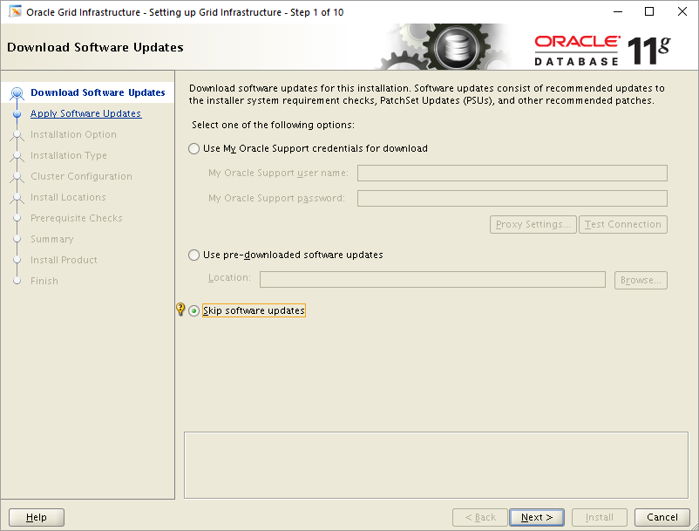
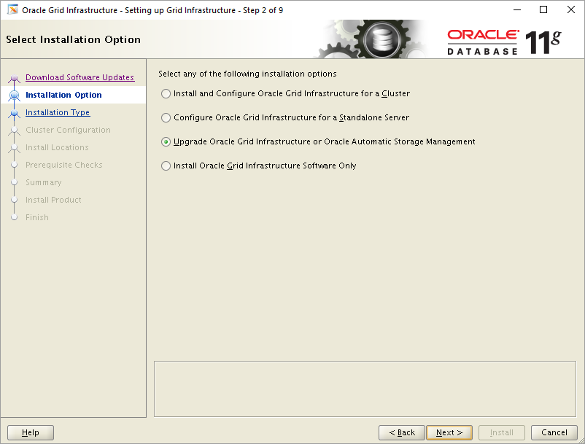
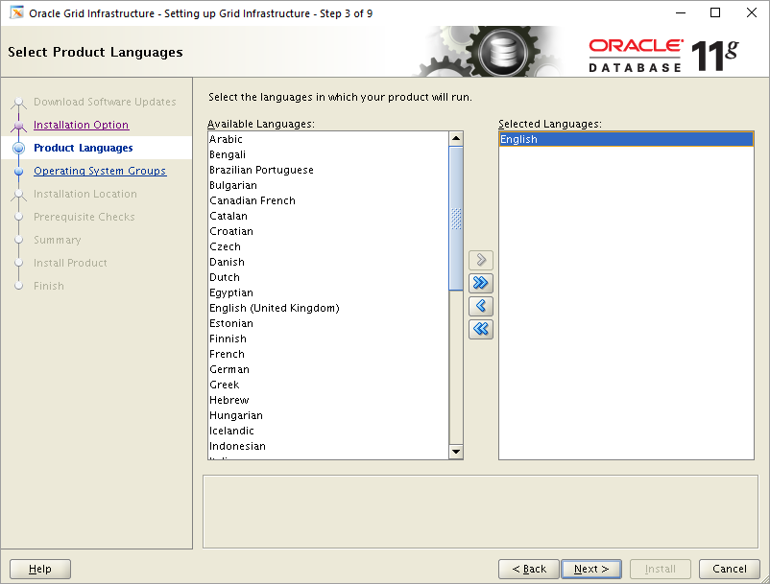
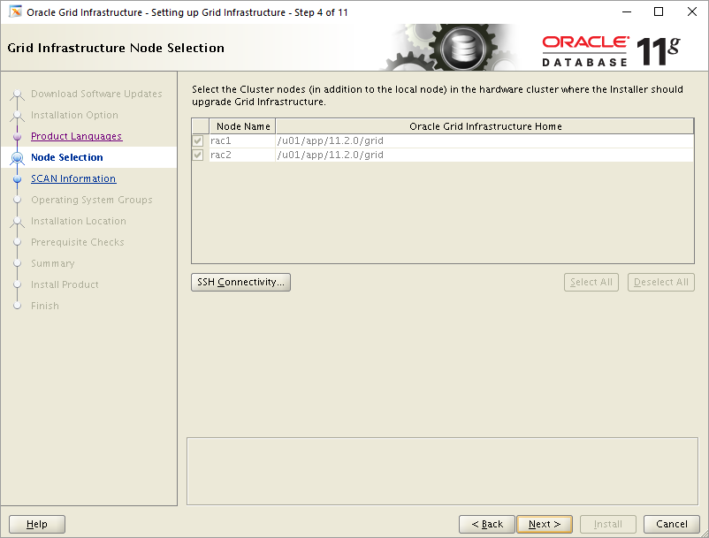
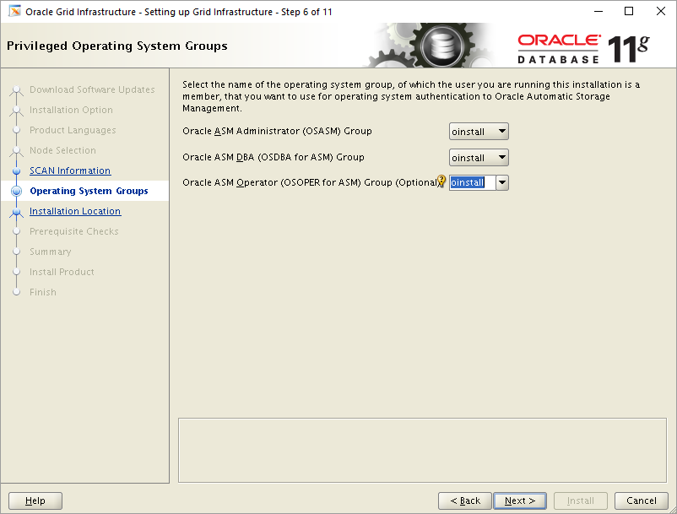
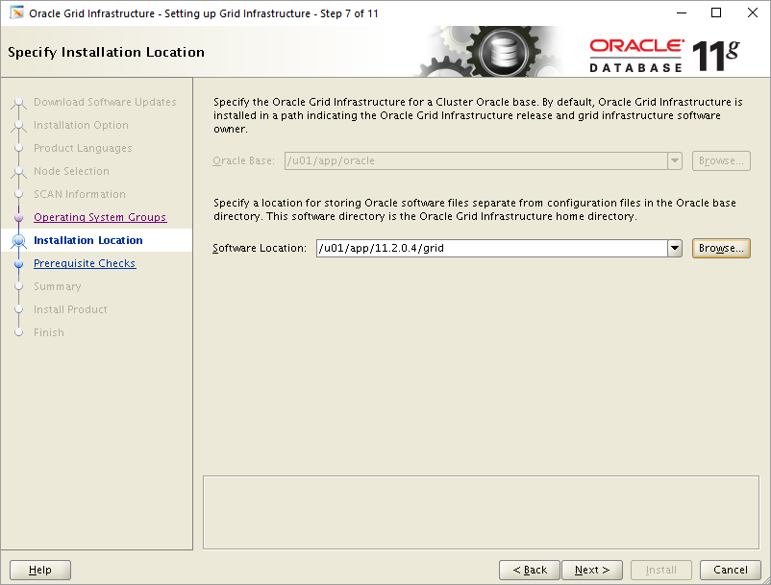
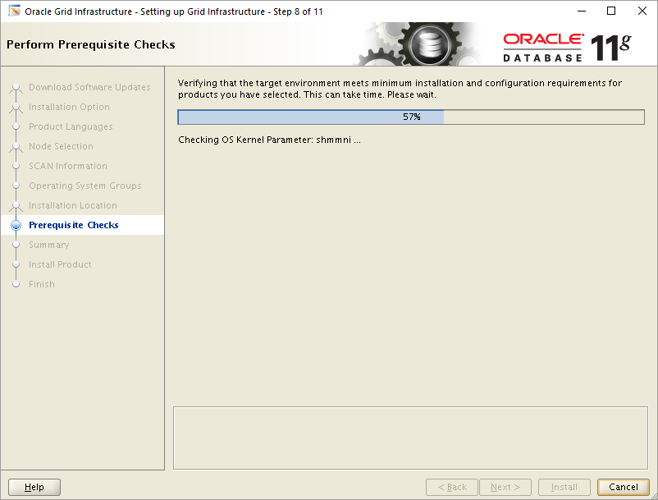
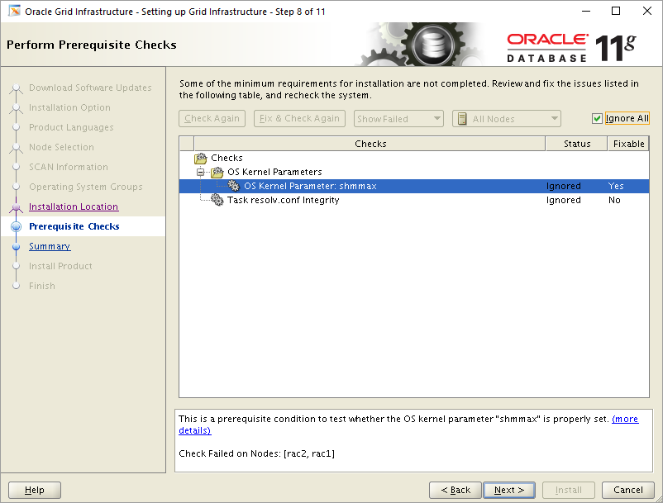
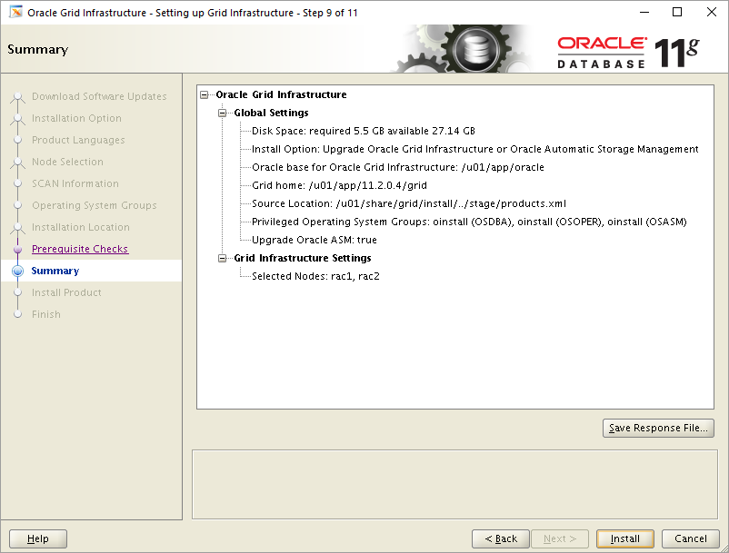
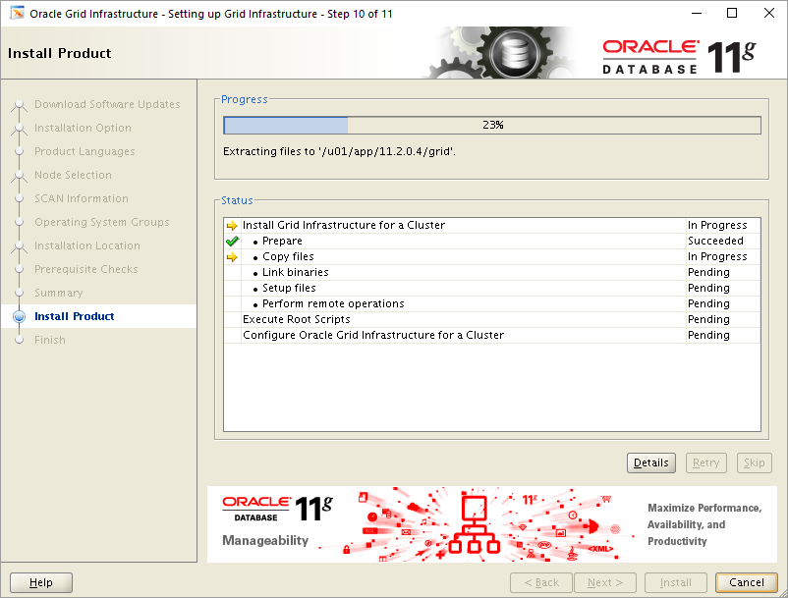
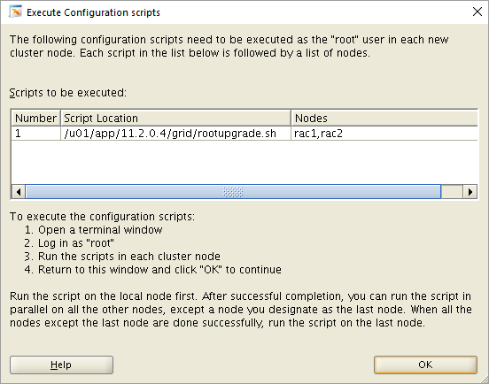
[root@rac1 ~]# /u01/app/11.2.0.4/grid/rootupgrade.sh
Performing root user operation for Oracle 11g

The following environment variables are set as:
ORACLE_OWNER= oracle
ORACLE_HOME= /u01/app/11.2.0.4/grid

Enter the full pathname of the local bin directory: [/usr/local/bin]:
The contents of "dbhome" have not changed. No need to overwrite.
The contents of "oraenv" have not changed. No need to overwrite.
The contents of "coraenv" have not changed. No need to overwrite.

Entries will be added to the /etc/oratab file as needed by
Database Configuration Assistant when a database is created
Finished running generic part of root script.
Now product-specific root actions will be performed.
Using configuration parameter file: /u01/app/11.2.0.4/grid/crs/install/crsconfig_params
Creating trace directory
User ignored Prerequisites during installation
Installing Trace File Analyzer

ASM upgrade has started on first node.

CRS-2791: Starting shutdown of Oracle High Availability Services-managed resources on 'rac1'
CRS-2673: Attempting to stop 'ora.crsd' on 'rac1'
CRS-2790: Starting shutdown of Cluster Ready Services-managed resources on 'rac1'
CRS-2673: Attempting to stop 'ora.scan3.vip' on 'rac1'
CRS-2673: Attempting to stop 'ora.oc4j' on 'rac1'
CRS-2673: Attempting to stop 'ora.LISTENER.lsnr' on 'rac1'
CRS-2673: Attempting to stop 'ora.scan2.vip' on 'rac1'
CRS-2673: Attempting to stop 'ora.OCR.dg' on 'rac1'
CRS-2673: Attempting to stop 'ora.cvu' on 'rac1'
CRS-2677: Stop of 'ora.scan3.vip' on 'rac1' succeeded
CRS-2672: Attempting to start 'ora.scan3.vip' on 'rac2'
CRS-2677: Stop of 'ora.scan2.vip' on 'rac1' succeeded
CRS-2672: Attempting to start 'ora.scan2.vip' on 'rac2'
CRS-2676: Start of 'ora.scan3.vip' on 'rac2' succeeded
CRS-2676: Start of 'ora.scan2.vip' on 'rac2' succeeded
CRS-2677: Stop of 'ora.LISTENER.lsnr' on 'rac1' succeeded
CRS-2673: Attempting to stop 'ora.rac1.vip' on 'rac1'
CRS-2677: Stop of 'ora.rac1.vip' on 'rac1' succeeded
CRS-2672: Attempting to start 'ora.rac1.vip' on 'rac2'
CRS-2676: Start of 'ora.rac1.vip' on 'rac2' succeeded
CRS-2677: Stop of 'ora.oc4j' on 'rac1' succeeded
CRS-2672: Attempting to start 'ora.oc4j' on 'rac2'
CRS-2677: Stop of 'ora.cvu' on 'rac1' succeeded
CRS-2672: Attempting to start 'ora.cvu' on 'rac2'
CRS-2676: Start of 'ora.cvu' on 'rac2' succeeded
CRS-2676: Start of 'ora.oc4j' on 'rac2' succeeded
CRS-2677: Stop of 'ora.OCR.dg' on 'rac1' succeeded
CRS-2673: Attempting to stop 'ora.asm' on 'rac1'
CRS-2677: Stop of 'ora.asm' on 'rac1' succeeded
CRS-2673: Attempting to stop 'ora.ons' on 'rac1'
CRS-2677: Stop of 'ora.ons' on 'rac1' succeeded
CRS-2673: Attempting to stop 'ora.net1.network' on 'rac1'
CRS-2677: Stop of 'ora.net1.network' on 'rac1' succeeded
CRS-2792: Shutdown of Cluster Ready Services-managed resources on 'rac1' has completed
CRS-2677: Stop of 'ora.crsd' on 'rac1' succeeded
CRS-2673: Attempting to stop 'ora.crf' on 'rac1'
CRS-2673: Attempting to stop 'ora.ctssd' on 'rac1'
CRS-2673: Attempting to stop 'ora.evmd' on 'rac1'
CRS-2673: Attempting to stop 'ora.asm' on 'rac1'
CRS-2673: Attempting to stop 'ora.mdnsd' on 'rac1'
CRS-2677: Stop of 'ora.crf' on 'rac1' succeeded
CRS-2677: Stop of 'ora.mdnsd' on 'rac1' succeeded
CRS-2677: Stop of 'ora.evmd' on 'rac1' succeeded
CRS-2677: Stop of 'ora.ctssd' on 'rac1' succeeded
CRS-2677: Stop of 'ora.asm' on 'rac1' succeeded
CRS-2673: Attempting to stop 'ora.cluster_interconnect.haip' on 'rac1'
CRS-2677: Stop of 'ora.cluster_interconnect.haip' on 'rac1' succeeded
CRS-2673: Attempting to stop 'ora.cssd' on 'rac1'
CRS-2677: Stop of 'ora.cssd' on 'rac1' succeeded
CRS-2673: Attempting to stop 'ora.gipcd' on 'rac1'
CRS-2677: Stop of 'ora.gipcd' on 'rac1' succeeded
CRS-2673: Attempting to stop 'ora.gpnpd' on 'rac1'
CRS-2677: Stop of 'ora.gpnpd' on 'rac1' succeeded
CRS-2793: Shutdown of Oracle High Availability Services-managed resources on 'rac1' has completed
CRS-4133: Oracle High Availability Services has been stopped.
OLR initialization - successful
Replacing Clusterware entries in inittab
clscfg: EXISTING configuration version 5 detected.
clscfg: version 5 is 11g Release 2.
Successfully accumulated necessary OCR keys.
Creating OCR keys for user 'root', privgrp 'root'..
Operation successful.
Configure Oracle Grid Infrastructure for a Cluster ... succeeded
[root@rac1 ~]#
[root@rac2 ~]# /u01/app/11.2.0.4/grid/rootupgrade.sh
Performing root user operation for Oracle 11g

The following environment variables are set as:
ORACLE_OWNER= oracle
ORACLE_HOME= /u01/app/11.2.0.4/grid

Enter the full pathname of the local bin directory: [/usr/local/bin]:
The contents of "dbhome" have not changed. No need to overwrite.
The contents of "oraenv" have not changed. No need to overwrite.
The contents of "coraenv" have not changed. No need to overwrite.

Entries will be added to the /etc/oratab file as needed by
Database Configuration Assistant when a database is created
Finished running generic part of root script.
Now product-specific root actions will be performed.
Using configuration parameter file: /u01/app/11.2.0.4/grid/crs/install/crsconfig _params
Creating trace directory
User ignored Prerequisites during installation
Installing Trace File Analyzer
CRS-2791: Starting shutdown of Oracle High Availability Services-managed resources on 'rac2'
CRS-2673: Attempting to stop 'ora.crsd' on 'rac2'
CRS-2790: Starting shutdown of Cluster Ready Services-managed resources on 'rac2'
CRS-2673: Attempting to stop 'ora.OCR.dg' on 'rac2'
CRS-2673: Attempting to stop 'ora.scan3.vip' on 'rac2'
CRS-2673: Attempting to stop 'ora.scan2.vip' on 'rac2'
CRS-2673: Attempting to stop 'ora.cvu' on 'rac2'
CRS-2673: Attempting to stop 'ora.LISTENER.lsnr' on 'rac2'
CRS-2677: Stop of 'ora.scan3.vip' on 'rac2' succeeded
CRS-2672: Attempting to start 'ora.scan3.vip' on 'rac1'
CRS-2677: Stop of 'ora.scan2.vip' on 'rac2' succeeded
CRS-2672: Attempting to start 'ora.scan2.vip' on 'rac1'
CRS-2677: Stop of 'ora.cvu' on 'rac2' succeeded
CRS-2672: Attempting to start 'ora.cvu' on 'rac1'
CRS-2677: Stop of 'ora.LISTENER.lsnr' on 'rac2' succeeded
CRS-2673: Attempting to stop 'ora.rac2.vip' on 'rac2'
CRS-2677: Stop of 'ora.rac2.vip' on 'rac2' succeeded
CRS-2672: Attempting to start 'ora.rac2.vip' on 'rac1'
CRS-2676: Start of 'ora.cvu' on 'rac1' succeeded
CRS-2676: Start of 'ora.scan3.vip' on 'rac1' succeeded
CRS-2676: Start of 'ora.scan2.vip' on 'rac1' succeeded
CRS-2676: Start of 'ora.rac2.vip' on 'rac1' succeeded
CRS-2677: Stop of 'ora.OCR.dg' on 'rac2' succeeded
CRS-2673: Attempting to stop 'ora.asm' on 'rac2'
CRS-2677: Stop of 'ora.asm' on 'rac2' succeeded
CRS-2673: Attempting to stop 'ora.ons' on 'rac2'
CRS-2677: Stop of 'ora.ons' on 'rac2' succeeded
CRS-2673: Attempting to stop 'ora.net1.network' on 'rac2'
CRS-2677: Stop of 'ora.net1.network' on 'rac2' succeeded
CRS-2792: Shutdown of Cluster Ready Services-managed resources on 'rac2' has completed
CRS-2677: Stop of 'ora.crsd' on 'rac2' succeeded
CRS-2673: Attempting to stop 'ora.mdnsd' on 'rac2'
CRS-2673: Attempting to stop 'ora.ctssd' on 'rac2'
CRS-2673: Attempting to stop 'ora.evmd' on 'rac2'
CRS-2673: Attempting to stop 'ora.asm' on 'rac2'
CRS-2677: Stop of 'ora.evmd' on 'rac2' succeeded
CRS-2677: Stop of 'ora.ctssd' on 'rac2' succeeded
CRS-2677: Stop of 'ora.mdnsd' on 'rac2' succeeded
CRS-2677: Stop of 'ora.asm' on 'rac2' succeeded
CRS-2673: Attempting to stop 'ora.cluster_interconnect.haip' on 'rac2'
CRS-2677: Stop of 'ora.cluster_interconnect.haip' on 'rac2' succeeded
CRS-2673: Attempting to stop 'ora.cssd' on 'rac2'
CRS-2677: Stop of 'ora.cssd' on 'rac2' succeeded
CRS-2673: Attempting to stop 'ora.crf' on 'rac2'
CRS-2677: Stop of 'ora.crf' on 'rac2' succeeded
CRS-2673: Attempting to stop 'ora.gipcd' on 'rac2'
CRS-2677: Stop of 'ora.gipcd' on 'rac2' succeeded
CRS-2673: Attempting to stop 'ora.gpnpd' on 'rac2'
CRS-2677: Stop of 'ora.gpnpd' on 'rac2' succeeded
CRS-2793: Shutdown of Oracle High Availability Services-managed resources on 'rac2' has completed
CRS-4133: Oracle High Availability Services has been stopped.
OLR initialization - successful
Replacing Clusterware entries in inittab
clscfg: EXISTING configuration version 5 detected.
clscfg: version 5 is 11g Release 2.
Successfully accumulated necessary OCR keys.
Creating OCR keys for user 'root', privgrp 'root'..
Operation successful.
Started to upgrade the Oracle Clusterware. This operation may take a few minutes.
Started to upgrade the CSS.
Started to upgrade the CRS.
The CRS was successfully upgraded.
Successfully upgraded the Oracle Clusterware.
Oracle Clusterware operating version was successfully set to 11.2.0.4.0

ASM upgrade has finished on last node.

Configure Oracle Grid Infrastructure for a Cluster ... succeeded
[root@rac2 ~]#
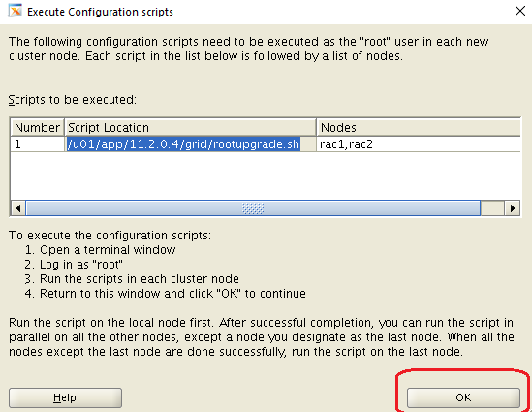
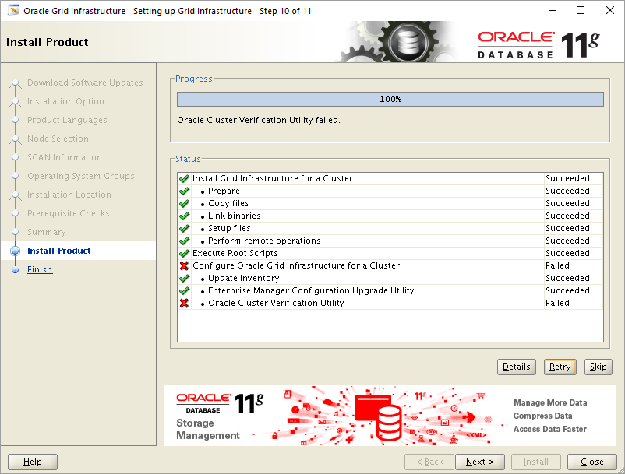
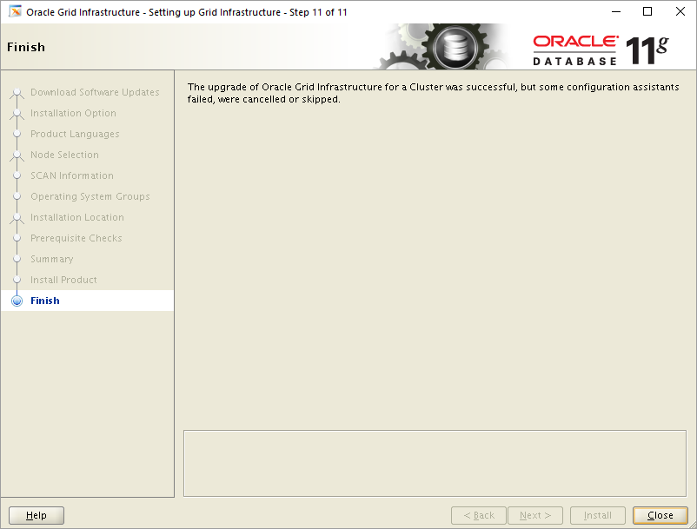
[root@rac1 ~]# crsctl query crs activeversion
Oracle Clusterware active version on the cluster is [11.2.0.4.0]
[root@rac1 ~]# crsctl query crs softwareversion
Oracle Clusterware version on node [rac1] is [11.2.0.4.0]
[root@rac1 ~]#
[root@rac2 ~]# crsctl query crs softwareversion
Oracle Clusterware version on node [rac2] is [11.2.0.4.0]
[root@rac2 ~]#
[root@rac1 ~]# crsctl check cluster -all
**************************************************************
rac1:
CRS-4537: Cluster Ready Services is online
CRS-4529: Cluster Synchronization Services is online
CRS-4533: Event Manager is online
**************************************************************
rac2:
CRS-4537: Cluster Ready Services is online
CRS-4529: Cluster Synchronization Services is online
CRS-4533: Event Manager is online
**************************************************************
[root@rac1 ~]#
[root@rac1 ~]# crsctl stat res -t
--------------------------------------------------------------------------------
NAME TARGET STATE SERVER STATE_DETAILS
--------------------------------------------------------------------------------
Local Resources
--------------------------------------------------------------------------------
ora.LISTENER.lsnr
ONLINE ONLINE rac1
ONLINE ONLINE rac2
ora.OCR.dg
ONLINE ONLINE rac1
ONLINE ONLINE rac2
ora.asm
ONLINE ONLINE rac1 Started
ONLINE ONLINE rac2 Started
ora.gsd
OFFLINE OFFLINE rac1
OFFLINE OFFLINE rac2
ora.net1.network
ONLINE ONLINE rac1
ONLINE ONLINE rac2
ora.ons
ONLINE ONLINE rac1
ONLINE ONLINE rac2
ora.registry.acfs
ONLINE ONLINE rac1
ONLINE ONLINE rac2
--------------------------------------------------------------------------------
Cluster Resources
--------------------------------------------------------------------------------
ora.LISTENER_SCAN1.lsnr
1 ONLINE ONLINE rac2
ora.cvu
1 ONLINE ONLINE rac1
ora.oc4j
1 ONLINE ONLINE rac2
ora.rac1.vip
1 ONLINE ONLINE rac1
ora.rac2.vip
1 ONLINE ONLINE rac2
ora.scan1.vip
1 ONLINE ONLINE rac2
ora.scan2.vip
1 ONLINE ONLINE rac1
ora.scan3.vip
1 ONLINE ONLINE rac1
[root@rac1 ~]#

