[root@rac1 ~]# cat /proc/partitions
major minor #blocks name

8 0 52428800 sda
8 1 10482381 sda1
8 2 36138217 sda2
8 3 5807497 sda3
8 16 1048576 sdb
8 17 1044193 sdb1
8 32 4194304 sdc
8 33 4192933 sdc1
[root@rac1 ~]#
[root@rac1 ~]# oracleasm createdisk disk1 /dev/sdb1
Writing disk header: done
Instantiating disk: done
[root@rac1 ~]# oracleasm createdisk disk2 /dev/sdc1
Writing disk header: done
Instantiating disk: done
[root@rac1 ~]#
[root@rac1 ~]# oracleasm listdisks
DISK1
DISK2
[root@rac1 ~]#

On Node2
[root@rac2 ~]# oracleasm listdisks
[root@rac2 ~]# oracleasm scandisks
Reloading disk partitions: done
Cleaning any stale ASM disks...
Scanning system for ASM disks...
Instantiating disk "DISK1"
Instantiating disk "DISK2"
[root@rac2 ~]# oracleasm listdisks
DISK1
DISK2
[root@rac2 ~]#

[oracle@rac1 grid]$ pwd
/home/oracle/grid
[oracle@rac1 grid]$ ls -ltr
total 104
-rwxrwx--- 1 oracle oinstall 4326 Sep 2 2011 welcome.html
-rwxrwx--- 1 oracle oinstall 4878 Sep 22 2011 runcluvfy.sh ------
-rwxrwx--- 1 oracle oinstall 3227 Sep 22 2011 runInstaller
-rwxrwx--- 1 oracle oinstall 28122 Sep 22 2011 readme.html
drwxrwx--- 2 oracle oinstall 4096 Dec 5 2013 sshsetup
drwxrwx--- 4 oracle oinstall 4096 Dec 5 2013 install
drwxrwx--- 2 oracle oinstall 4096 Dec 5 2013 rpm
drwxrwx--- 2 oracle oinstall 4096 Dec 5 2013 response
drwxrwx--- 9 oracle oinstall 4096 Dec 5 2013 doc
drwxrwx--- 14 oracle oinstall 4096 Dec 5 2013 stage
-rw-r--r-- 1 oracle oinstall 30181 Dec 8 2013 clufy.log
[oracle@rac1 grid]$

[oracle@rac1 grid]$ ./runcluvfy.sh comp ssa -n rac1,rac2 -verbose

Verifying shared storage accessibility

Checking shared storage accessibility...

Disk Sharing Nodes (2 in count)
------------------------------------ ------------------------
/dev/sdb rac2 rac1

Disk Sharing Nodes (2 in count)
------------------------------------ ------------------------
/dev/sdc rac2 rac1

Shared storage check was successful on nodes "rac2,rac1"

Verification of shared storage accessibility was successful.
[oracle@rac1 grid]$

[oracle@rac1 grid]$ ./runcluvfy.sh stage -pre crsinst -n rac1,rac2 -verbose

Performing pre-checks for cluster services setup

Checking node reachability...

Check: Node reachability from node "rac1"
Destination Node Reachable?
------------------------------------ ------------------------
rac2 yes
rac1 yes
Result: Node reachability check passed from node "rac1"

Checking user equivalence...

Check: User equivalence for user "oracle"
Node Name Status
------------------------------------ ------------------------
rac2 passed
rac1 passed
Result: User equivalence check passed for user "oracle"

Checking node connectivity...

Checking hosts config file...
Node Name Status
------------------------------------ ------------------------
rac2 passed
rac1 passed

Verification of the hosts config file successful

Interface information for node "rac2"
Name IP Address Subnet Gateway Def. Gateway HW Address MTU
------ --------------- --------------- --------------- --------------- ----------------- ------
eth0 192.168.2.102 192.168.2.0 0.0.0.0 192.168.2.1 08:00:27:3E:C3:CC 1500
eth1 192.168.0.102 192.168.0.0 0.0.0.0 192.168.2.1 08:00:27:AD:B3:4F 1500

Interface information for node "rac1"
Name IP Address Subnet Gateway Def. Gateway HW Address MTU
------ --------------- --------------- --------------- --------------- ----------------- ------
eth0 192.168.2.101 192.168.2.0 0.0.0.0 192.168.2.1 08:00:27:7B:F1:29 1500
eth1 192.168.0.101 192.168.0.0 0.0.0.0 192.168.2.1 08:00:27:3F:4C:D9 1500

Check: Node connectivity of subnet "192.168.2.0"
Source Destination Connected?
------------------------------ ------------------------------ ----------------
rac2[192.168.2.102] rac1[192.168.2.101] yes
Result: Node connectivity passed for subnet "192.168.2.0" with node(s) rac2,rac1

Check: TCP connectivity of subnet "192.168.2.0"
Source Destination Connected?
------------------------------ ------------------------------ ----------------
rac1:192.168.2.101 rac2:192.168.2.102 passed
Result: TCP connectivity check passed for subnet "192.168.2.0"

Check: Node connectivity of subnet "192.168.0.0"
Source Destination Connected?
------------------------------ ------------------------------ ----------------
rac2[192.168.0.102] rac1[192.168.0.101] yes
Result: Node connectivity passed for subnet "192.168.0.0" with node(s) rac2,rac1

Check: TCP connectivity of subnet "192.168.0.0"
Source Destination Connected?
------------------------------ ------------------------------ ----------------
rac1:192.168.0.101 rac2:192.168.0.102 passed
Result: TCP connectivity check passed for subnet "192.168.0.0"

Interfaces found on subnet "192.168.2.0" that are likely candidates for VIP are:
rac2 eth0:192.168.2.102
rac1 eth0:192.168.2.101

Interfaces found on subnet "192.168.0.0" that are likely candidates for a private interconnect are:
rac2 eth1:192.168.0.102
rac1 eth1:192.168.0.101
Checking subnet mask consistency...
Subnet mask consistency check passed for subnet "192.168.2.0".
Subnet mask consistency check passed for subnet "192.168.0.0".
Subnet mask consistency check passed.

Result: Node connectivity check passed

Checking multicast communication...

Checking subnet "192.168.2.0" for multicast communication with multicast group "230.0.1.0"...
Check of subnet "192.168.2.0" for multicast communication with multicast group "230.0.1.0" passed.

Checking subnet "192.168.0.0" for multicast communication with multicast group "230.0.1.0"...
Check of subnet "192.168.0.0" for multicast communication with multicast group "230.0.1.0" passed.

Check of multicast communication passed.

Checking ASMLib configuration.
Node Name Status
------------------------------------ ------------------------
rac2 passed
rac1 passed
Result: Check for ASMLib configuration passed.

Check: Total memory
Node Name Available Required Status
------------ ------------------------ ------------------------ ----------
rac2 2.942GB (3084860.0KB) 1.5GB (1572864.0KB) passed
rac1 2.942GB (3084860.0KB) 1.5GB (1572864.0KB) passed
Result: Total memory check passed

Check: Available memory
Node Name Available Required Status
------------ ------------------------ ------------------------ ----------
rac2 2.7764GB (2911292.0KB) 50MB (51200.0KB) passed
rac1 2.6908GB (2821512.0KB) 50MB (51200.0KB) passed
Result: Available memory check passed

Check: Swap space
Node Name Available Required Status
------------ ------------------------ ------------------------ ----------
rac2 5.5385GB (5807488.0KB) 2.942GB (3084860.0KB) passed
rac1 5.5385GB (5807488.0KB) 2.942GB (3084860.0KB) passed
Result: Swap space check passed

Check: Free disk space for "rac2:/tmp"
Path Node Name Mount point Available Required Status
---------------- ------------ ------------ ------------ ------------ ------------
/tmp rac2 / 4.9248GB 1GB passed
Result: Free disk space check passed for "rac2:/tmp"

Check: Free disk space for "rac1:/tmp"
Path Node Name Mount point Available Required Status
---------------- ------------ ------------ ------------ ------------ ------------
/tmp rac1 / 4.9043GB 1GB passed
Result: Free disk space check passed for "rac1:/tmp"

Check: User existence for "oracle"
Node Name Status Comment
------------ ------------------------ ------------------------
rac2 passed exists(1100)
rac1 passed exists(1100)

Checking for multiple users with UID value 1100
Result: Check for multiple users with UID value 1100 passed
Result: User existence check passed for "oracle"

Check: Group existence for "oinstall"
Node Name Status Comment
------------ ------------------------ ------------------------
rac2 passed exists
rac1 passed exists
Result: Group existence check passed for "oinstall"

Check: Group existence for "dba"
Node Name Status Comment
------------ ------------------------ ------------------------
rac2 passed exists
rac1 passed exists
Result: Group existence check passed for "dba"

Check: Membership of user "oracle" in group "oinstall" [as Primary]
Node Name User Exists Group Exists User in Group Primary Status
---------------- ------------ ------------ ------------ ------------ ------------
rac2 yes yes yes yes passed
rac1 yes yes yes yes passed
Result: Membership check for user "oracle" in group "oinstall" [as Primary] passed

Check: Membership of user "oracle" in group "dba"
Node Name User Exists Group Exists User in Group Status
---------------- ------------ ------------ ------------ ----------------
rac2 yes yes yes passed
rac1 yes yes yes passed
Result: Membership check for user "oracle" in group "dba" passed

Check: Run level
Node Name run level Required Status
------------ ------------------------ ------------------------ ----------
rac2 5 3,5 passed
rac1 5 3,5 passed
Result: Run level check passed

Check: Hard limits for "maximum open file descriptors"
Node Name Type Available Required Status
---------------- ------------ ------------ ------------ ----------------
rac2 hard 65536 65536 passed
rac1 hard 65536 65536 passed
Result: Hard limits check passed for "maximum open file descriptors"

Check: Soft limits for "maximum open file descriptors"
Node Name Type Available Required Status
---------------- ------------ ------------ ------------ ----------------
rac2 soft 1024 1024 passed
rac1 soft 1024 1024 passed
Result: Soft limits check passed for "maximum open file descriptors"

Check: Hard limits for "maximum user processes"
Node Name Type Available Required Status
---------------- ------------ ------------ ------------ ----------------
rac2 hard 16384 16384 passed
rac1 hard 16384 16384 passed
Result: Hard limits check passed for "maximum user processes"

Check: Soft limits for "maximum user processes"
Node Name Type Available Required Status
---------------- ------------ ------------ ------------ ----------------
rac2 soft 2047 2047 passed
rac1 soft 2047 2047 passed
Result: Soft limits check passed for "maximum user processes"

Check: System architecture
Node Name Available Required Status
------------ ------------------------ ------------------------ ----------
rac2 x86_64 x86_64 passed
rac1 x86_64 x86_64 passed
Result: System architecture check passed

Check: Kernel version
Node Name Available Required Status
------------ ------------------------ ------------------------ ----------
rac2 2.6.32-200.13.1.el5uek 2.6.18 passed
rac1 2.6.32-200.13.1.el5uek 2.6.18 passed
Result: Kernel version check passed

Check: Kernel parameter for "semmsl"
Node Name Current Configured Required Status Comment
---------------- ------------ ------------ ------------ ------------ ------------
rac2 250 250 250 passed
rac1 250 250 250 passed
Result: Kernel parameter check passed for "semmsl"

Check: Kernel parameter for "semmns"
Node Name Current Configured Required Status Comment
---------------- ------------ ------------ ------------ ------------ ------------
rac2 32000 32000 32000 passed
rac1 32000 32000 32000 passed
Result: Kernel parameter check passed for "semmns"

Check: Kernel parameter for "semopm"
Node Name Current Configured Required Status Comment
---------------- ------------ ------------ ------------ ------------ ------------
rac2 100 100 100 passed
rac1 100 100 100 passed
Result: Kernel parameter check passed for "semopm"

Check: Kernel parameter for "semmni"
Node Name Current Configured Required Status Comment
---------------- ------------ ------------ ------------ ------------ ------------
rac2 128 128 128 passed
rac1 128 128 128 passed
Result: Kernel parameter check passed for "semmni"

Check: Kernel parameter for "shmmax"
Node Name Current Configured Required Status Comment
---------------- ------------ ------------ ------------ ------------ ------------
rac2 1054504960 1054504960 1579448320 failed Current value too low. Configured value too low.
rac1 1054504960 1054504960 1579448320 failed Current value too low. Configured value too low.
Result: Kernel parameter check failed for "shmmax"

Check: Kernel parameter for "shmmni"
Node Name Current Configured Required Status Comment
---------------- ------------ ------------ ------------ ------------ ------------
rac2 4096 4096 4096 passed
rac1 4096 4096 4096 passed
Result: Kernel parameter check passed for "shmmni"

Check: Kernel parameter for "shmall"
Node Name Current Configured Required Status Comment
---------------- ------------ ------------ ------------ ------------ ------------
rac2 2097152 2097152 2097152 passed
rac1 2097152 2097152 2097152 passed
Result: Kernel parameter check passed for "shmall"

Check: Kernel parameter for "file-max"
Node Name Current Configured Required Status Comment
---------------- ------------ ------------ ------------ ------------ ------------
rac2 6815744 6815744 6815744 passed
rac1 6815744 6815744 6815744 passed
Result: Kernel parameter check passed for "file-max"

Check: Kernel parameter for "ip_local_port_range"
Node Name Current Configured Required Status Comment
---------------- ------------ ------------ ------------ ------------ ------------
rac2 between 9000.0 & 65500.0 between 9000.0 & 65500.0 between 9000.0 & 65500.0 passed
rac1 between 9000.0 & 65500.0 between 9000.0 & 65500.0 between 9000.0 & 65500.0 passed
Result: Kernel parameter check passed for "ip_local_port_range"

Check: Kernel parameter for "rmem_default"
Node Name Current Configured Required Status Comment
---------------- ------------ ------------ ------------ ------------ ------------
rac2 262144 262144 262144 passed
rac1 262144 262144 262144 passed
Result: Kernel parameter check passed for "rmem_default"

Check: Kernel parameter for "rmem_max"
Node Name Current Configured Required Status Comment
---------------- ------------ ------------ ------------ ------------ ------------
rac2 4194304 4194304 4194304 passed
rac1 4194304 4194304 4194304 passed
Result: Kernel parameter check passed for "rmem_max"

Check: Kernel parameter for "wmem_default"
Node Name Current Configured Required Status Comment
---------------- ------------ ------------ ------------ ------------ ------------
rac2 262144 262144 262144 passed
rac1 262144 262144 262144 passed
Result: Kernel parameter check passed for "wmem_default"

Check: Kernel parameter for "wmem_max"
Node Name Current Configured Required Status Comment
---------------- ------------ ------------ ------------ ------------ ------------
rac2 1048586 1048586 1048576 passed
rac1 1048586 1048586 1048576 passed
Result: Kernel parameter check passed for "wmem_max"

Check: Kernel parameter for "aio-max-nr"
Node Name Current Configured Required Status Comment
---------------- ------------ ------------ ------------ ------------ ------------
rac2 65536 unknown 1048576 failed Current value too low. Configured value too low.
rac1 65536 unknown 1048576 failed Current value too low. Configured value too low.
Result: Kernel parameter check failed for "aio-max-nr"

Check: Package existence for "make"
Node Name Available Required Status
------------ ------------------------ ------------------------ ----------
rac2 make-3.81-3.el5 make-3.81 passed
rac1 make-3.81-3.el5 make-3.81 passed
Result: Package existence check passed for "make"

Check: Package existence for "binutils"
Node Name Available Required Status
------------ ------------------------ ------------------------ ----------
rac2 binutils-2.17.50.0.6-14.el5 binutils-2.17.50.0.6 passed
rac1 binutils-2.17.50.0.6-14.el5 binutils-2.17.50.0.6 passed
Result: Package existence check passed for "binutils"

Check: Package existence for "gcc(x86_64)"
Node Name Available Required Status
------------ ------------------------ ------------------------ ----------
rac2 gcc(x86_64)-4.1.2-51.el5 gcc(x86_64)-4.1.2 passed
rac1 gcc(x86_64)-4.1.2-51.el5 gcc(x86_64)-4.1.2 passed
Result: Package existence check passed for "gcc(x86_64)"

Check: Package existence for "libaio(x86_64)"
Node Name Available Required Status
------------ ------------------------ ------------------------ ----------
rac2 libaio(x86_64)-0.3.106-5 libaio(x86_64)-0.3.106 passed
rac1 libaio(x86_64)-0.3.106-5 libaio(x86_64)-0.3.106 passed
Result: Package existence check passed for "libaio(x86_64)"

Check: Package existence for "glibc(x86_64)"
Node Name Available Required Status
------------ ------------------------ ------------------------ ----------
rac2 glibc(x86_64)-2.5-65 glibc(x86_64)-2.5-24 passed
rac1 glibc(x86_64)-2.5-65 glibc(x86_64)-2.5-24 passed
Result: Package existence check passed for "glibc(x86_64)"

Check: Package existence for "compat-libstdc++-33(x86_64)"
Node Name Available Required Status
------------ ------------------------ ------------------------ ----------
rac2 compat-libstdc++-33(x86_64)-3.2.3-61 compat-libstdc++-33(x86_64)-3.2.3 passed
rac1 compat-libstdc++-33(x86_64)-3.2.3-61 compat-libstdc++-33(x86_64)-3.2.3 passed
Result: Package existence check passed for "compat-libstdc++-33(x86_64)"

Check: Package existence for "elfutils-libelf(x86_64)"
Node Name Available Required Status
------------ ------------------------ ------------------------ ----------
rac2 elfutils-libelf(x86_64)-0.137-3.el5 elfutils-libelf(x86_64)-0.125 passed
rac1 elfutils-libelf(x86_64)-0.137-3.el5 elfutils-libelf(x86_64)-0.125 passed
Result: Package existence check passed for "elfutils-libelf(x86_64)"

Check: Package existence for "elfutils-libelf-devel"
Node Name Available Required Status
------------ ------------------------ ------------------------ ----------
rac2 elfutils-libelf-devel-0.137-3.el5 elfutils-libelf-devel-0.125 passed
rac1 elfutils-libelf-devel-0.137-3.el5 elfutils-libelf-devel-0.125 passed
Result: Package existence check passed for "elfutils-libelf-devel"

Check: Package existence for "glibc-common"
Node Name Available Required Status
------------ ------------------------ ------------------------ ----------
rac2 glibc-common-2.5-65 glibc-common-2.5 passed
rac1 glibc-common-2.5-65 glibc-common-2.5 passed
Result: Package existence check passed for "glibc-common"

Check: Package existence for "glibc-devel(x86_64)"
Node Name Available Required Status
------------ ------------------------ ------------------------ ----------
rac2 glibc-devel(x86_64)-2.5-65 glibc-devel(x86_64)-2.5 passed
rac1 glibc-devel(x86_64)-2.5-65 glibc-devel(x86_64)-2.5 passed
Result: Package existence check passed for "glibc-devel(x86_64)"

Check: Package existence for "glibc-headers"
Node Name Available Required Status
------------ ------------------------ ------------------------ ----------
rac2 glibc-headers-2.5-65 glibc-headers-2.5 passed
rac1 glibc-headers-2.5-65 glibc-headers-2.5 passed
Result: Package existence check passed for "glibc-headers"

Check: Package existence for "gcc-c++(x86_64)"
Node Name Available Required Status
------------ ------------------------ ------------------------ ----------
rac2 gcc-c++(x86_64)-4.1.2-51.el5 gcc-c++(x86_64)-4.1.2 passed
rac1 gcc-c++(x86_64)-4.1.2-51.el5 gcc-c++(x86_64)-4.1.2 passed
Result: Package existence check passed for "gcc-c++(x86_64)"

Check: Package existence for "libaio-devel(x86_64)"
Node Name Available Required Status
------------ ------------------------ ------------------------ ----------
rac2 libaio-devel(x86_64)-0.3.106-5 libaio-devel(x86_64)-0.3.106 passed
rac1 libaio-devel(x86_64)-0.3.106-5 libaio-devel(x86_64)-0.3.106 passed
Result: Package existence check passed for "libaio-devel(x86_64)"

Check: Package existence for "libgcc(x86_64)"
Node Name Available Required Status
------------ ------------------------ ------------------------ ----------
rac2 libgcc(x86_64)-4.1.2-51.el5 libgcc(x86_64)-4.1.2 passed
rac1 libgcc(x86_64)-4.1.2-51.el5 libgcc(x86_64)-4.1.2 passed
Result: Package existence check passed for "libgcc(x86_64)"

Check: Package existence for "libstdc++(x86_64)"
Node Name Available Required Status
------------ ------------------------ ------------------------ ----------
rac2 libstdc++(x86_64)-4.1.2-51.el5 libstdc++(x86_64)-4.1.2 passed
rac1 libstdc++(x86_64)-4.1.2-51.el5 libstdc++(x86_64)-4.1.2 passed
Result: Package existence check passed for "libstdc++(x86_64)"

Check: Package existence for "libstdc++-devel(x86_64)"
Node Name Available Required Status
------------ ------------------------ ------------------------ ----------
rac2 libstdc++-devel(x86_64)-4.1.2-51.el5 libstdc++-devel(x86_64)-4.1.2 passed
rac1 libstdc++-devel(x86_64)-4.1.2-51.el5 libstdc++-devel(x86_64)-4.1.2 passed
Result: Package existence check passed for "libstdc++-devel(x86_64)"

Check: Package existence for "sysstat"
Node Name Available Required Status
------------ ------------------------ ------------------------ ----------
rac2 sysstat-7.0.2-11.el5 sysstat-7.0.2 passed
rac1 sysstat-7.0.2-11.el5 sysstat-7.0.2 passed
Result: Package existence check passed for "sysstat"

Check: Package existence for "ksh"
Node Name Available Required Status
------------ ------------------------ ------------------------ ----------
rac2 ksh-20100202-1.el5_6.6 ksh-20060214 passed
rac1 ksh-20100202-1.el5_6.6 ksh-20060214 passed
Result: Package existence check passed for "ksh"

Checking for multiple users with UID value 0
Result: Check for multiple users with UID value 0 passed

Check: Current group ID
Result: Current group ID check passed

Starting check for consistency of primary group of root user
Node Name Status
------------------------------------ ------------------------
rac2 passed
rac1 passed

Check for consistency of root user's primary group passed

Starting Clock synchronization checks using Network Time Protocol(NTP)...

NTP Configuration file check started...
Network Time Protocol(NTP) configuration file not found on any of the nodes. Oracle Cluster Time Synchronization Service(CTSS) can be used instead of NTP for time synchronization on the cluster nodes
No NTP Daemons or Services were found to be running

Result: Clock synchronization check using Network Time Protocol(NTP) passed

Checking Core file name pattern consistency...
Core file name pattern consistency check passed.

Checking to make sure user "oracle" is not in "root" group
Node Name Status Comment
------------ ------------------------ ------------------------
rac2 passed does not exist
rac1 passed does not exist
Result: User "oracle" is not part of "root" group. Check passed

Check default user file creation mask
Node Name Available Required Comment
------------ ------------------------ ------------------------ ----------
rac2 0022 0022 passed
rac1 0022 0022 passed
Result: Default user file creation mask check passed
Checking consistency of file "/etc/resolv.conf" across nodes

Checking the file "/etc/resolv.conf" to make sure only one of domain and search entries is defined
File "/etc/resolv.conf" does not have both domain and search entries defined
Checking if domain entry in file "/etc/resolv.conf" is consistent across the nodes...
domain entry in file "/etc/resolv.conf" is consistent across nodes
Checking if search entry in file "/etc/resolv.conf" is consistent across the nodes...
search entry in file "/etc/resolv.conf" is consistent across nodes
Checking DNS response time for an unreachable node
Node Name Status
------------------------------------ ------------------------
rac2 failed
rac1 failed
PRVF-5636 : The DNS response time for an unreachable node exceeded "15000" ms on following nodes: rac2,rac1

File "/etc/resolv.conf" is not consistent across nodes

Check: Time zone consistency
Result: Time zone consistency check passed

Pre-check for cluster services setup was unsuccessful on all the nodes.
[oracle@rac1 grid]$

[oracle@rac1 grid]$ export DISPLAY=192.168.2.2:0.0
[oracle@rac1 grid]$ xclock
Warning: Missing charsets in String to FontSet conversion
[oracle@rac1 grid]$
[oracle@rac1 grid]$ ./runInstaller
Starting Oracle Universal Installer...

Checking Temp space: must be greater than 120 MB. Actual 4808 MB Passed
Checking swap space: must be greater than 150 MB. Actual 5671 MB Passed
Checking monitor: must be configured to display at least 256 colors. Actual 16777216 Passed
Preparing to launch Oracle Universal Installer from /tmp/OraInstall2015-12-16_08-10-31PM. Please wait ...
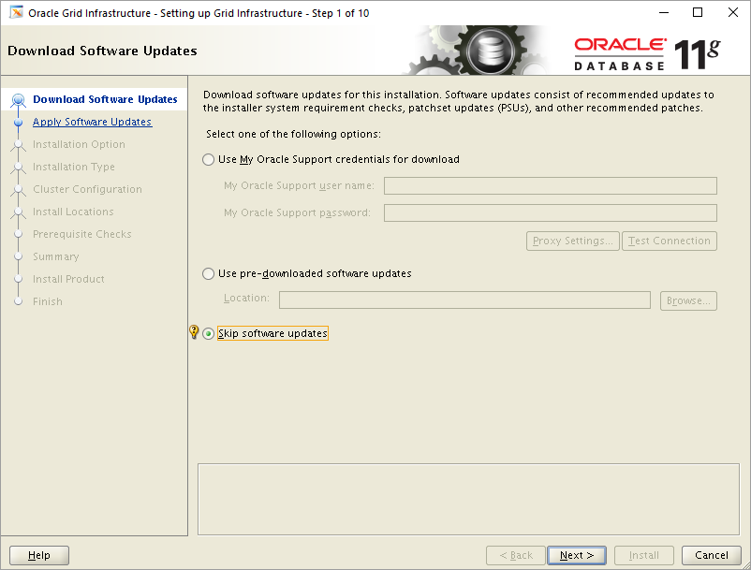
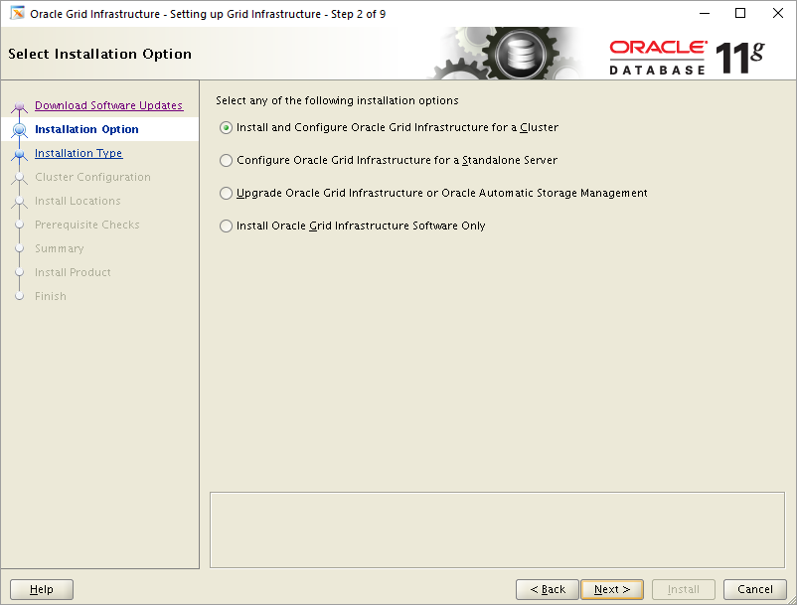
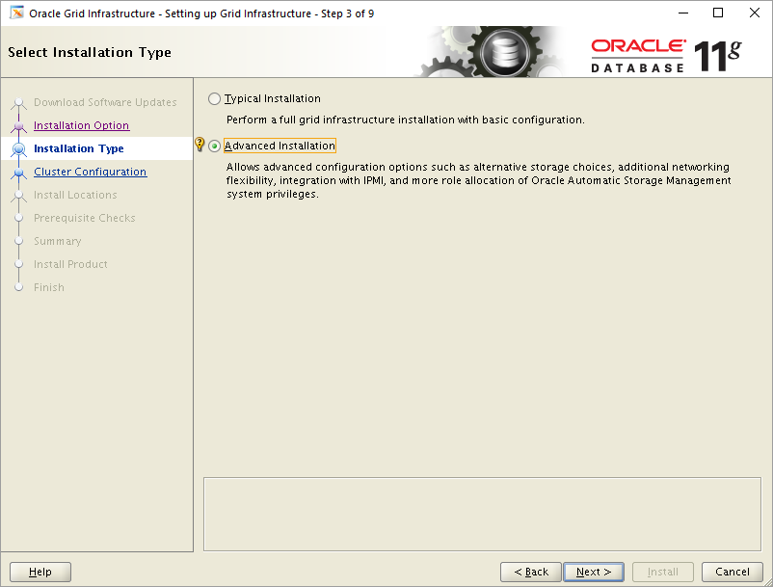
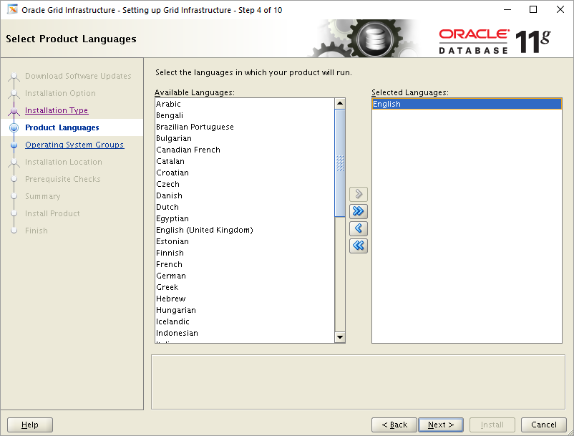
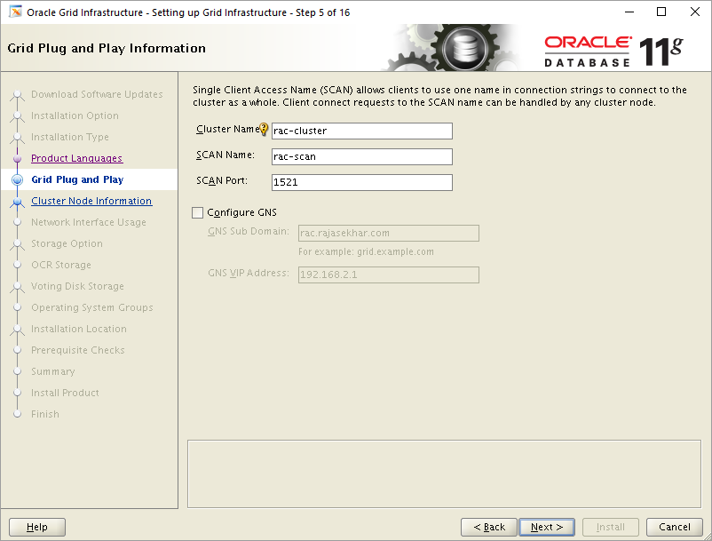
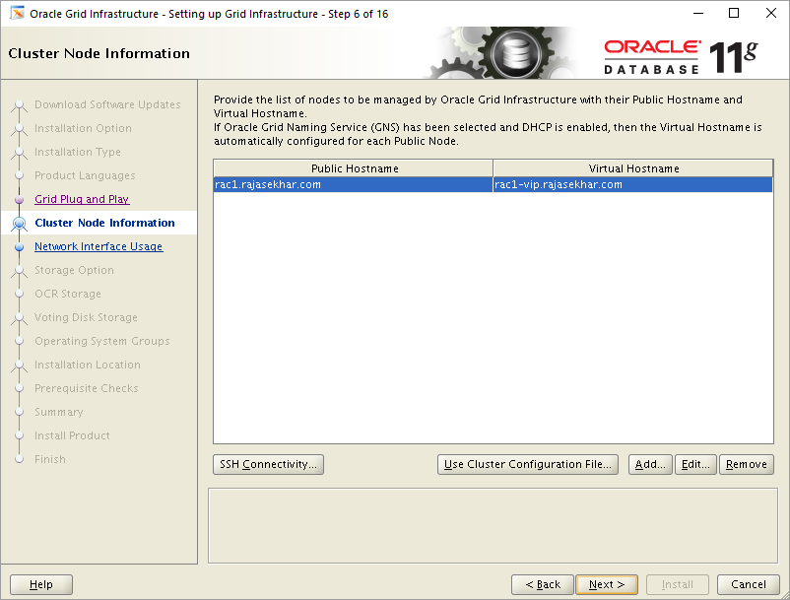
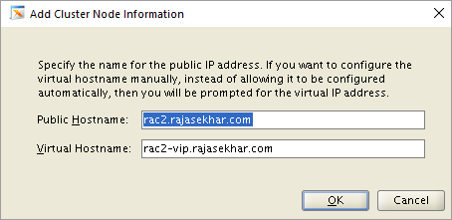
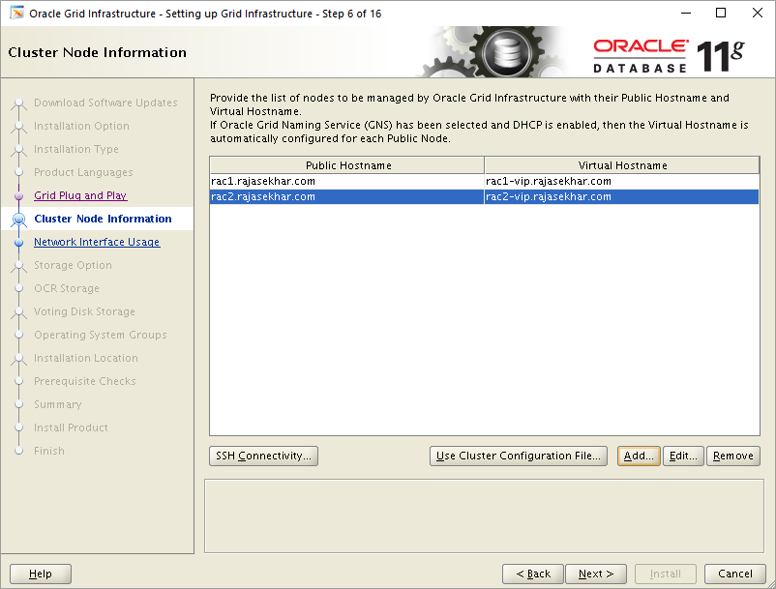
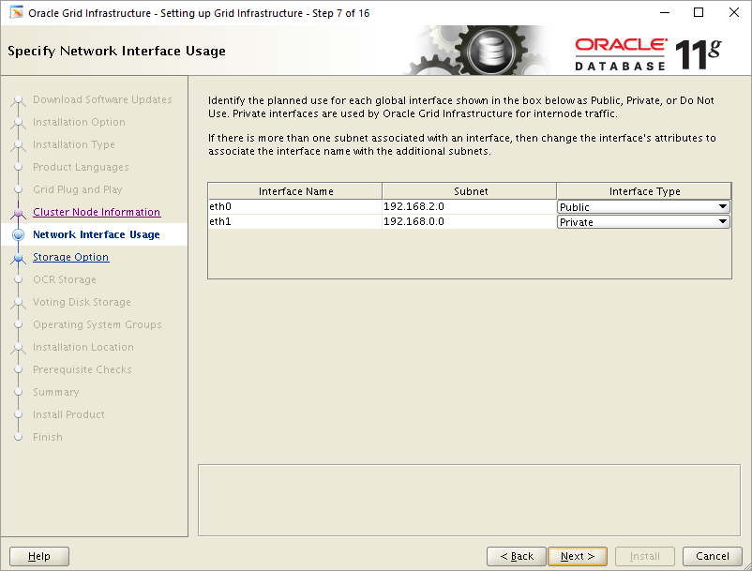
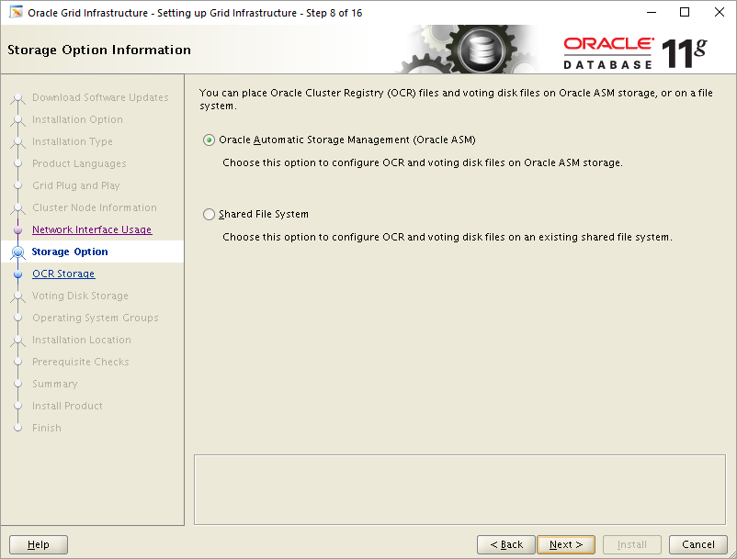
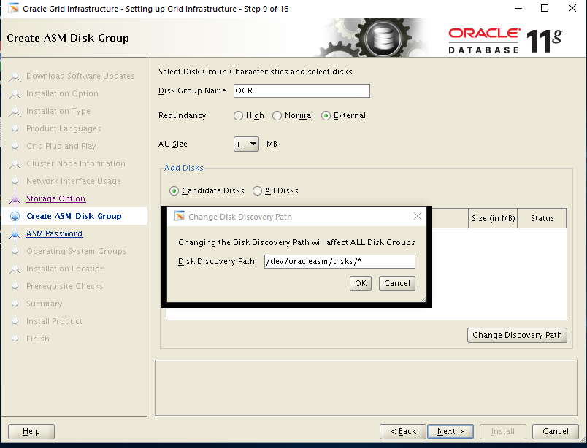
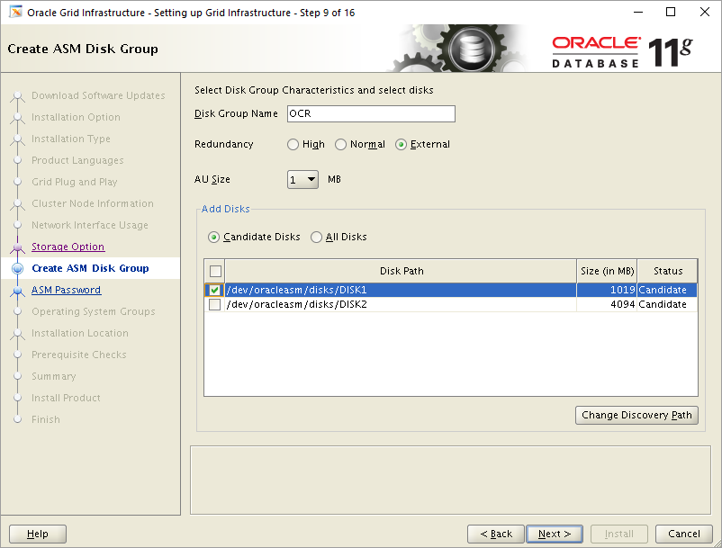
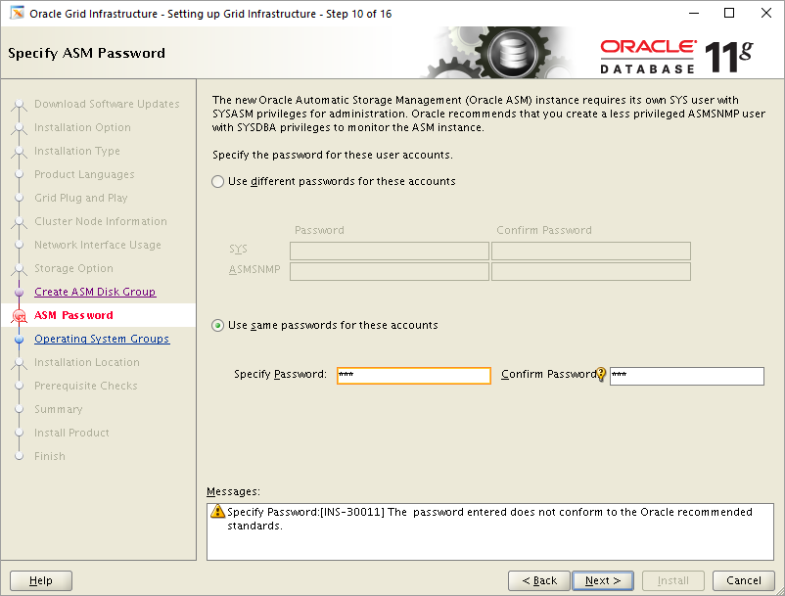
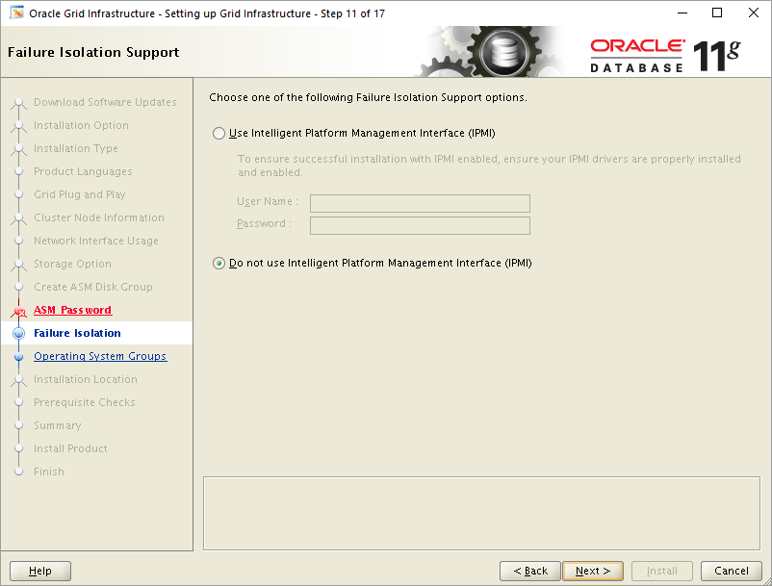
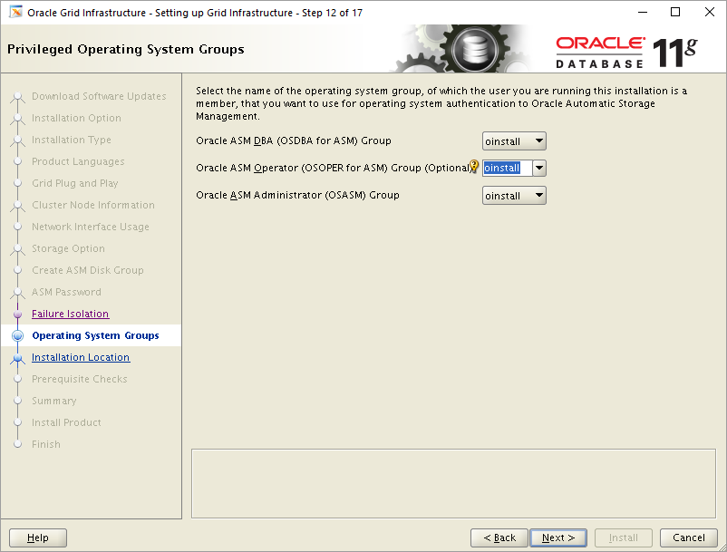
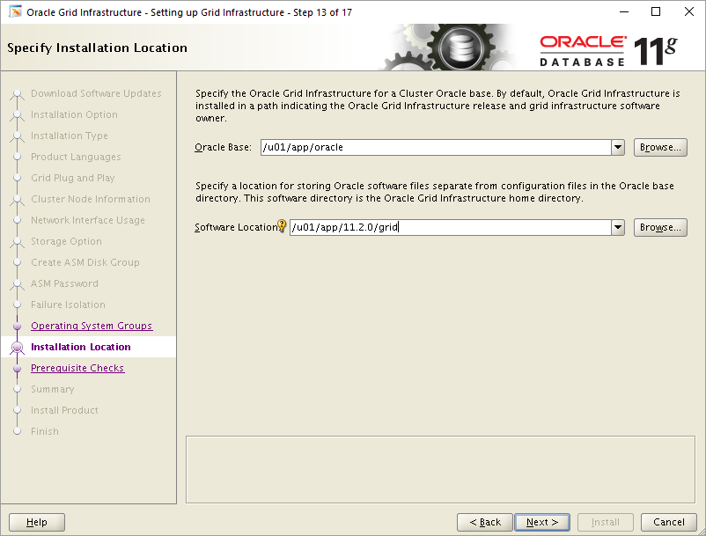
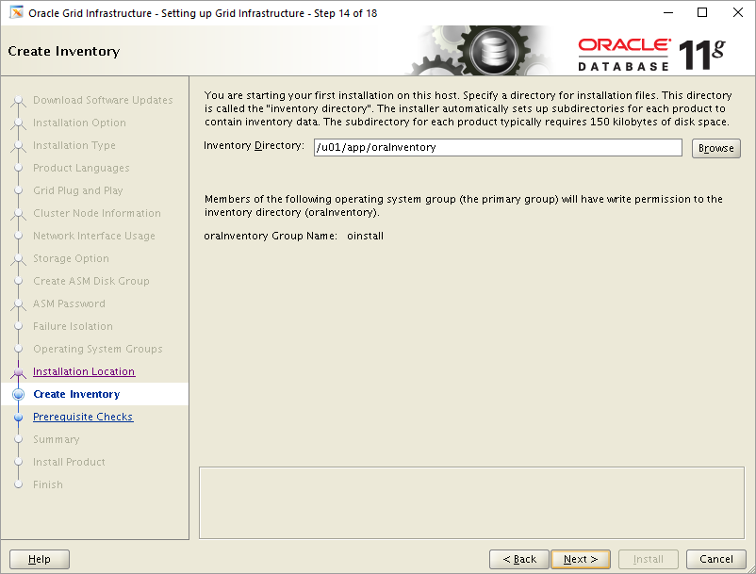
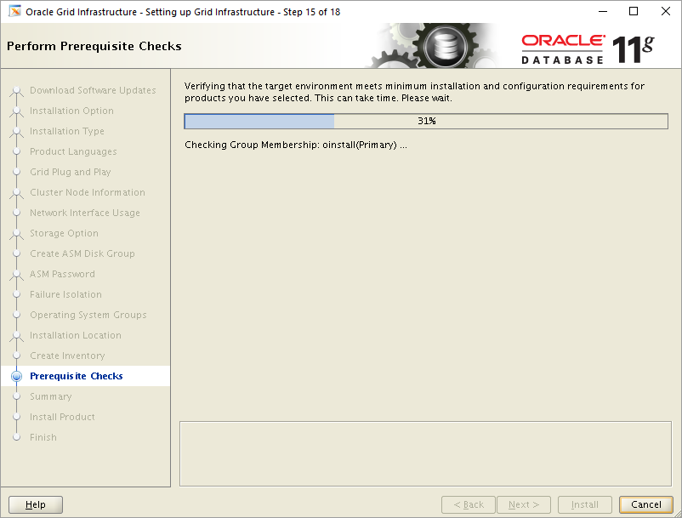
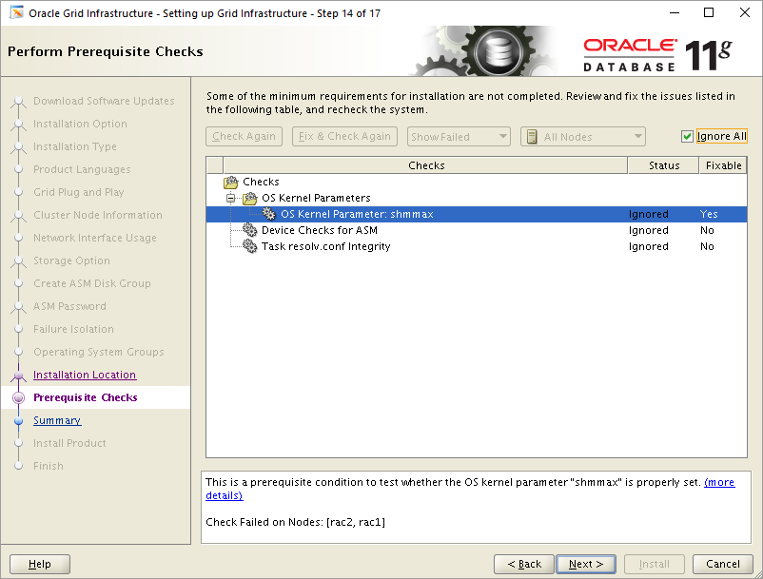

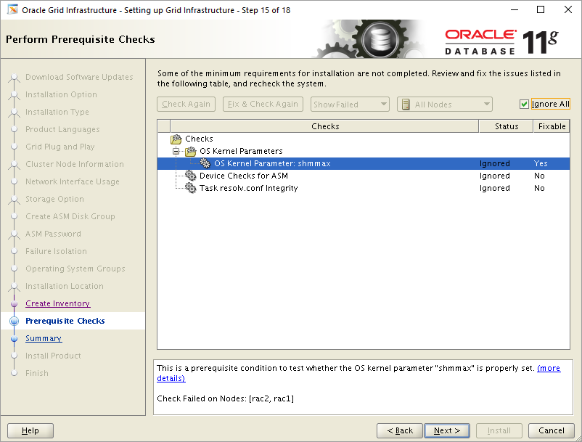
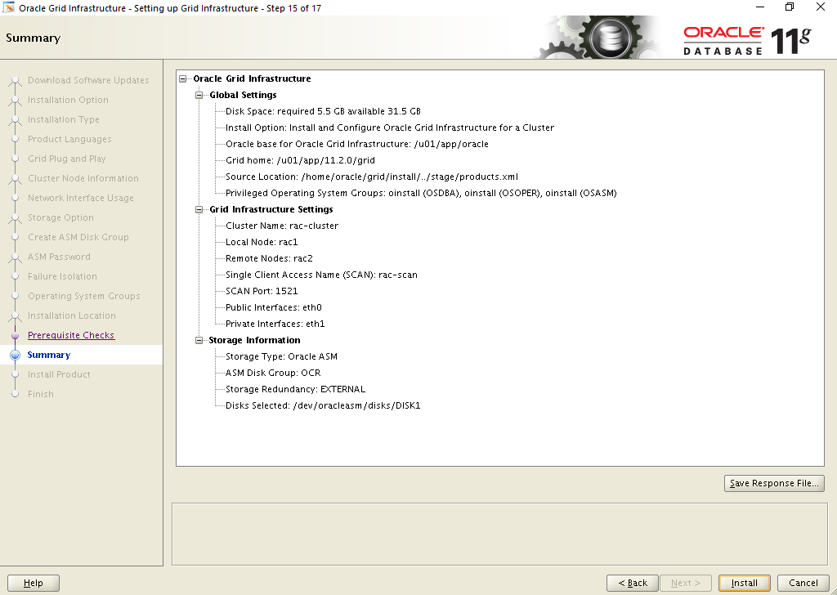
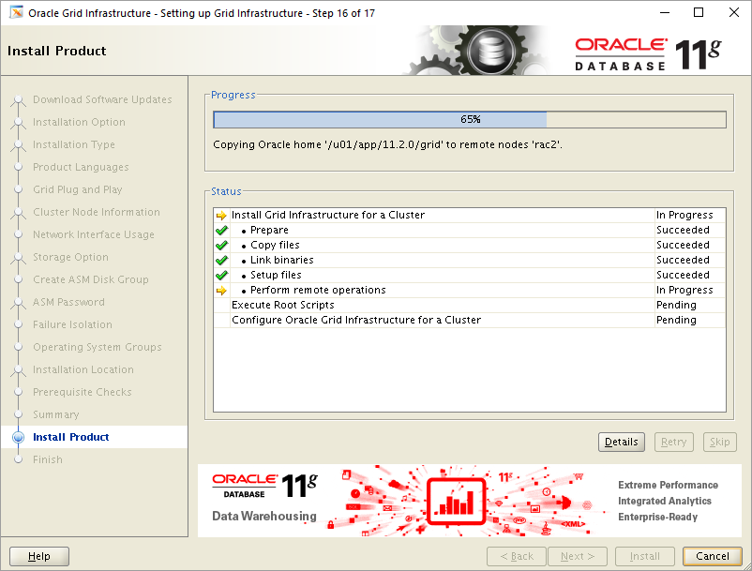
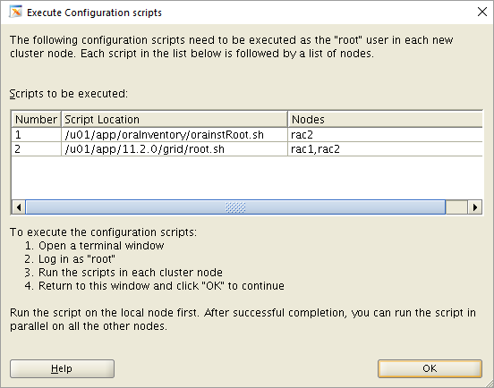
[root@rac1 ~]# /u01/app/oraInventory/orainstRoot.sh
Changing permissions of /u01/app/oraInventory.
Adding read,write permissions for group.
Removing read,write,execute permissions for world.

Changing groupname of /u01/app/oraInventory to oinstall.
The execution of the script is complete.
[root@rac1 ~]#
[root@rac1 ~]# /u01/app/11.2.0/grid/root.sh
Performing root user operation for Oracle 11g

The following environment variables are set as:
ORACLE_OWNER= oracle
ORACLE_HOME= /u01/app/11.2.0/grid

Enter the full pathname of the local bin directory: [/usr/local/bin]:
Copying dbhome to /usr/local/bin ...
Copying oraenv to /usr/local/bin ...
Copying coraenv to /usr/local/bin ...

Creating /etc/oratab file...
Entries will be added to the /etc/oratab file as needed by
Database Configuration Assistant when a database is created
Finished running generic part of root script.
Now product-specific root actions will be performed.
Using configuration parameter file: /u01/app/11.2.0/grid/crs/install/crsconfig_params
Creating trace directory
User ignored Prerequisites during installation
OLR initialization - successful
root wallet
root wallet cert
root cert export
peer wallet
profile reader wallet
pa wallet
peer wallet keys
pa wallet keys
peer cert request
pa cert request
peer cert
pa cert
peer root cert TP
profile reader root cert TP
pa root cert TP
peer pa cert TP
pa peer cert TP
profile reader pa cert TP
profile reader peer cert TP
peer user cert
pa user cert
Adding Clusterware entries to inittab
CRS-2672: Attempting to start 'ora.mdnsd' on 'rac1'
CRS-2676: Start of 'ora.mdnsd' on 'rac1' succeeded
CRS-2672: Attempting to start 'ora.gpnpd' on 'rac1'
CRS-2676: Start of 'ora.gpnpd' on 'rac1' succeeded
CRS-2672: Attempting to start 'ora.cssdmonitor' on 'rac1'
CRS-2672: Attempting to start 'ora.gipcd' on 'rac1'
CRS-2676: Start of 'ora.cssdmonitor' on 'rac1' succeeded
CRS-2676: Start of 'ora.gipcd' on 'rac1' succeeded
CRS-2672: Attempting to start 'ora.cssd' on 'rac1'
CRS-2672: Attempting to start 'ora.diskmon' on 'rac1'
CRS-2676: Start of 'ora.diskmon' on 'rac1' succeeded
CRS-2676: Start of 'ora.cssd' on 'rac1' succeeded

ASM created and started successfully.

Disk Group OCR created successfully.

clscfg: -install mode specified
Successfully accumulated necessary OCR keys.
Creating OCR keys for user 'root', privgrp 'root'..
Operation successful.
CRS-4256: Updating the profile
Successful addition of voting disk 62ac1979716d4f75bf2ce861b58e97e2.
Successfully replaced voting disk group with +OCR.
CRS-4256: Updating the profile
CRS-4266: Voting file(s) successfully replaced
## STATE File Universal Id File Name Disk group
-- ----- ----------------- --------- ---------
1. ONLINE 62ac1979716d4f75bf2ce861b58e97e2 (/dev/oracleasm/disks/DISK1) [OCR]
Located 1 voting disk(s).
CRS-2672: Attempting to start 'ora.asm' on 'rac1'
CRS-2676: Start of 'ora.asm' on 'rac1' succeeded
CRS-2672: Attempting to start 'ora.OCR.dg' on 'rac1'
CRS-2676: Start of 'ora.OCR.dg' on 'rac1' succeeded
Configure Oracle Grid Infrastructure for a Cluster ... succeeded
[root@rac1 ~]#
[root@rac2 ~]# /u01/app/oraInventory/orainstRoot.sh
Changing permissions of /u01/app/oraInventory.
Adding read,write permissions for group.
Removing read,write,execute permissions for world.

Changing groupname of /u01/app/oraInventory to oinstall.
The execution of the script is complete.
[root@rac2 ~]#
[root@rac2 ~]# /u01/app/11.2.0/grid/root.sh
Performing root user operation for Oracle 11g

The following environment variables are set as:
ORACLE_OWNER= oracle
ORACLE_HOME= /u01/app/11.2.0/grid

Enter the full pathname of the local bin directory: [/usr/local/bin]:
Copying dbhome to /usr/local/bin ...
Copying oraenv to /usr/local/bin ...
Copying coraenv to /usr/local/bin ...

Creating /etc/oratab file...
Entries will be added to the /etc/oratab file as needed by
Database Configuration Assistant when a database is created
Finished running generic part of root script.
Now product-specific root actions will be performed.
Using configuration parameter file: /u01/app/11.2.0/grid/crs/install/crsconfig_params
Creating trace directory
User ignored Prerequisites during installation
OLR initialization - successful
Adding Clusterware entries to inittab
CRS-4402: The CSS daemon was started in exclusive mode but found an active CSS daemon on node rac1, number 1, and is terminating
An active cluster was found during exclusive startup, restarting to join the cluster
Configure Oracle Grid Infrastructure for a Cluster ... succeeded
[root@rac2 ~]#
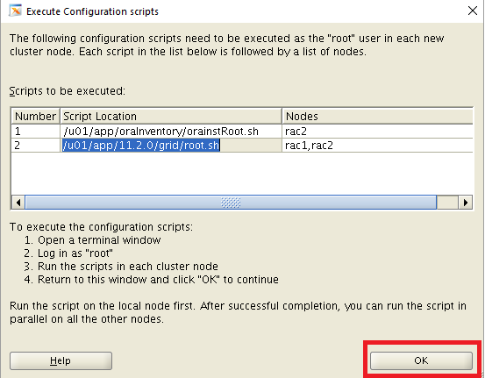
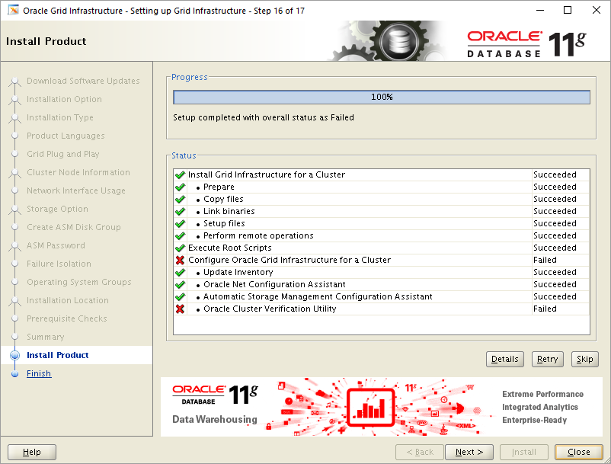
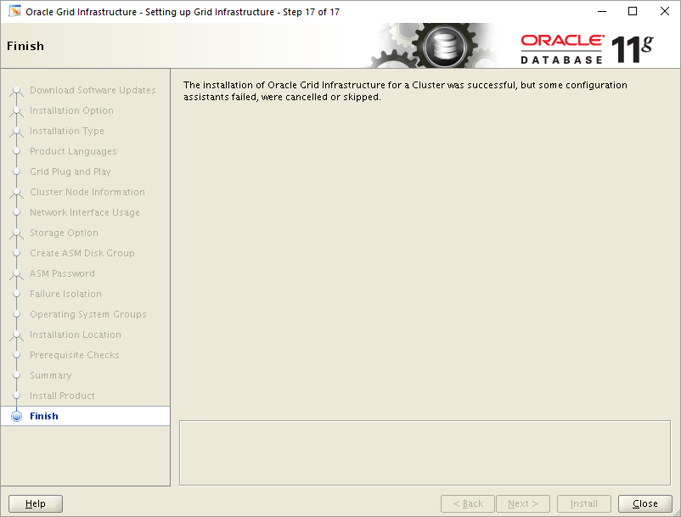
[root@rac1 ~]# . oraenv
ORACLE_SID = [root] ? +ASM1
The Oracle base has been set to /u01/app/oracle
[root@rac1 ~]# crsctl check cluster -all
**************************************************************
rac1:
CRS-4537: Cluster Ready Services is online
CRS-4529: Cluster Synchronization Services is online
CRS-4533: Event Manager is online
**************************************************************
rac2:
CRS-4537: Cluster Ready Services is online
CRS-4529: Cluster Synchronization Services is online
CRS-4533: Event Manager is online
**************************************************************
[root@rac1 ~]#
[root@rac1 ~]# crsctl stat res -t
--------------------------------------------------------------------------------
NAME TARGET STATE SERVER STATE_DETAILS
--------------------------------------------------------------------------------
Local Resources
--------------------------------------------------------------------------------
ora.LISTENER.lsnr
ONLINE ONLINE rac1
ONLINE ONLINE rac2
ora.OCR.dg
ONLINE ONLINE rac1
ONLINE ONLINE rac2
ora.asm
ONLINE ONLINE rac1 Started
ONLINE ONLINE rac2 Started
ora.gsd
OFFLINE OFFLINE rac1
OFFLINE OFFLINE rac2
ora.net1.network
ONLINE ONLINE rac1
ONLINE ONLINE rac2
ora.ons
ONLINE ONLINE rac1
ONLINE ONLINE rac2
--------------------------------------------------------------------------------
Cluster Resources
--------------------------------------------------------------------------------
ora.LISTENER_SCAN1.lsnr
1 ONLINE ONLINE rac1
ora.cvu
1 ONLINE ONLINE rac1
ora.oc4j
1 ONLINE ONLINE rac1
ora.rac1.vip
1 ONLINE ONLINE rac1
ora.rac2.vip
1 ONLINE ONLINE rac2
ora.scan1.vip
1 ONLINE ONLINE rac1
[root@rac1 ~]#

